INDIAN SIGN LANGUAGE RECOGNITION SYSTEM USING YOLOv5

BACHELOR OF TECHNOLOGY

IN

ELECTRONICS AND COMMUNICATION ENGINEERING

By

G.ALEKHYA

UNDER THE GUIDANCE OF UBS TEAM





## ABSTRACT

Effective communication is fundamental to human interaction, yet traditional methods like speech pose challenges for certain individuals, including those who are deaf, hard of hearing, mute, or nonverbal. For these individuals, sign language serves as a crucial mode of expression and connection with others. Sign language, comprising movements and visual messages, facilitates integration into vocal communication-centric communities. Communication by speaking prevails among the various ways of self-expression and communication between people. Speech presents a significant challenge for some disabled people, such as deaf people, deaf and hard of hearing, dumb and wordless persons. Therefore, these people rely on sign language to interact with others. Sign language is a system of movements and visual messages that ensure the integration of these individuals into groups that communicate vocally. On the other side, it is necessary to understand these individuals’ gestures and linguistic semantics. The main objective of this work is to establish a new model that enhances the performance of the existing paradigms used for sign language recognition. However, understanding the gestures and linguistic nuances of sign language is essential for effective communication.

This study aims to enhance existing paradigms for sign language recognition through the development of three novel deep learning models, leveraging YOLOv5x and attention mechanisms. Specifically, the models focus on recognizing alphabetic and numeric hand gestures, crucial for conveying information in sign language. The proposed models are evaluated using Indian Sign Language (ISL) datasets, demonstrating superior performance compared to existing literature. Achieving an accuracy of 98% with the MU Hand Images ISL dataset, the models exhibit efficiency and speed suitable for real-time ISL recognition. Moreover, their lightweight nature enables deployment on edge-based platforms, expanding accessibility to sign language recognition technology.

**Keywords**: Signlanguage, Communication, Deeplearning, YOLOv5, Attention mechanisms, Indian Sign Language (ISL), Hand Gesture Recognition, Real-Time Recognition, Edge Computing.

## TABLE OF CONTENTS

**CONTENT PAGE NUMBER**

|  |  |
| --- | --- |
| Certificate | II |
| Dissertation Approval Sheet | III |
| Declaration | IV |
| Acknowledgement | V |
| Abstract | VI |
| Contents | VII |
| List of Figures | IX |
| **CHAPTER 1: INTRODUCTION** |  |
| 1.1 Purpose | 1 |
| 1.2 Scope | 1 |
| 1.3 Motivation | 1 |
| 1.4 ISL Recognition by Yolo Overview | 2 |
| 1.4.1 Approaches for Sign Language Recognition | 2 |
| 1.4.1.1 Glove-Based Approach | 3 |
| 1.4.1.2 Computer Vision-Based Approach | 5 |
| 1.5 Proposed Algorithm | 7 |
| 1.6 Proposed System | 9 |
| **CHAPTER 2: LITERATURE SURVEY** |  |
| 2.1 Introduction to Literature Survey | 10 |
| 2.2 Literature Survey | 10 |
| **CHAPTER 3: SYSTEM ANALYSIS** |  |
| 3.1 Introduction | 12 |
| 3.2 Problem statement | 12 |
| 3.3 Existing System | 12 |
| 3.4 Modules Description | 14 |
| **CHAPTER 4**: **SYSTEM REQUIREMENTS SPECIFICATION** |  |
| 4.1 Software Requirements | 16 |
| 4.2 Hardware Requirements | 16 |
| 4.3 Project Perquisites | 16 |
| **CHAPTER 5: SYSTEM DESIGN**  5.1 Introduction | 20 |
| 5.2 System Model | 20 |
| 5.3 System Architecture | 21 |
| 5.4 YOLOv5 Architecture  5.4.1 C3 Module  5.4.2 CBS Module  5.4.3 CSPDarknet  5.4.4 SPP and SPPF Module  5.4.5 Feature Pyramid Network (FPN)  5.4.6 Path Aggregation Network (PANet)  5.5 Attention Mechanism  5.5.1 SE Module (Squeeze-and-Excitation)  5.5.2 CBAM (Convolutional Block Attention Module) | 22  27  28  29  30  31  33  38  39  40 |
| **CHAPTER 6: IMPLEMENTATION** |  |
| 6.1 Technology Description  6.1.1 Techniques Used | 43  43 |
| 6.2 Sample code | 44 |
| **CHAPTER 7: SCREENSHOTS** |  |
| 7 Output Screenshots | 63 |
| **CHAPTER 8: TESTING** |  |
| 8 Visualizing the training metrics | 66 |
| **CHAPTER 9: CONCLUSION AND FURTHER ENHANCEMENTS** |  |
| 9. Conclusion and Further Enhancements | 72 |
| **CHAPTER 10: REFERENCES** |  |
| 10. References | 74 |
| **PAPER PUBLICATION** |  |
|  |  |

**LIST OF FIGURES**

|  |  |
| --- | --- |
| **Figure** | **Page Number** |
| Figure -1.1 Types of Approaches | 2 |
| Figure -1.2 Glove Mechanism | 3 |
| Figure -1.3 Working of Glove Mechanism | 3 |
| Figure -1.4 Hardware component of Glove Approach | 4 |
| Figure -1.5 Process of Computer Vision | 5 |
| Figure -1.6 Image Acquisition | 5 |
| Figure -1.7 Image Segmentation | 6 |
| Figure -1.8 Feature Extraction | 15 |
| Figure -1.9 Mechanism of Preprocessing | 16 |
| Figure -1.10 Flow Chart of Proposed Algorithm | 17 |
| Figure -3.1 Mechanism of Existing System | 17 |
| Figure -5.1 Model Architecture | 18 |
| Figure -5.2 Flowchart of Yolov5 | 18 |
| Figure -5.3 Backbone of Yolov5 | 19 |
| Figure -5.4 Neck of Yolov5 | 19 |
| Figure -5.5 Head of Yolov5 | 19 |
| Figure -5.6 Different Versions of Yolov5 | 20 |
| Figure - 5.7 Mechanism of Yolov5 | 20 |
| Figure -5.8 C3 Module | 26 |
| Figure -5.9 Darknet53 | 26 |
| Figure -5.10 SPPF & SPP Architecture | 27 |
| Figure -5.11 RepLK-SPP module | 27 |
| Figure -5.12 Architecture of Feature Pyramid Network | 28 |
| Figure -5.13 Flowchart Path Aggregation Network | 30 |
| Figure -5.14 Architecture of Path Aggregation Network | 31 |

|  |  |
| --- | --- |
| Figure -5.15 Path Aggregation Network Instance Segmentation | 31 |
| Figure -5.16 YOLOv4: Optimal Speed & Object Detection | 32 |
| Figure -5.17 SE Module (Squeeze-and-Excitation) | 32 |
| Figure -5.18 Architecture of SE Module (Squeeze-and-Excitation) | 33 |
| Figure -5.19 CBAM (Convolutional Block Attention Module) | 33 |
| Figure -5.20 Attention Mechanism | 34 |
| Figure -6.1 Model of YOLO  Figure - 7.1 Undetected Images  Figure - 7.2 Detected Images  Figure - 8.1 Evaluation Metrics  Figure - 8.2 Graphs of Evaluation Metrices | 34    63    64    68  69 |

CHAPTER-1

# INTRODUCTION

### Purpose

The main goal of indian sign language recognition using YOLOv5 is to determine the hand signs with the ISL dataset and assist the deaf and dumb people with the hand signs which can able to recognize.

The study aims to enhance sign language recognition by integrating YOLOv5x with attention mechanisms, addressing communication barriers for individuals with hearing impairments. By leveraging attention modules like Squeeze-and-Excitation (SE) and Convolutional Block Attention Module (CBAM), the models achieve improved precision, recall, and mean Average Precision (mAP). Evaluation using the MU HandImages ISL dataset demonstrates superior performance compared to existing literature, with recognition rates exceeding 98%. These lightweight models enable real-time gesture detection suitable for deployment on edge-based platforms, fostering inclusivity and accessibility in communication for the deaf community.

### Scope

The scope of the model encompasses the development of advanced deep learning techniques for sign language recognition, specifically focusing on Indian Sign Language (ISL) gestures. By integrating YOLOv5x with attention mechanisms, the model aims to achieve superior precision and recall rates, enhancing its ability to interpret a wide range of ISL gestures accurately. Additionally, the model targets real-time performance, enabling deployment on edge-based platforms such as smartphones and wearable devices. This broad scope encompasses both technical advancements and practical applications, contributing to the accessibility and inclusivity of communication for individuals with hearing impairments.

The goal of indian sign language detection is to recognize the hand signs according to the ISL signatures. As a result, our project attempts to develop a technique that can identify the hand signs which can be effectively and easily understand by the deaf and dumb people.

### Motivation

The goal of indian sign language recognition is to ensure the no communication gap between the physically impaired and the normal people in the society. The primary motivation behind the model is to bridge the communication gap between individuals with hearing impairments, such as the deaf and dumb, and those without disabilities. By accurately interpreting sign language gestures, the model enables seamless interaction between these two groups, fostering inclusivity and understanding. This technology empowers individuals with hearing impairments to express themselves effectively and facilitates meaningful communication with the broader community.

Ultimately, the model aims to promote social integration, break down communication barriers, and create a more inclusive society where everyone can participate equally in conversations and interactions.

### ISL Recognition by Yolo Overview

Sign language serves as a vital mode of communication for individuals with hearing impairments, enabling them to express themselves and interact with others effectively. However, recognizing and interpreting sign language gestures present unique challenges, necessitating the development of specialized technology for sign language recognition. In this context, the integration of advanced deep learning techniques, particularly YOLOv5x with attention mechanisms, has emerged as a promising approach to enhance the accuracy and efficiency of Indian Sign Language (ISL) recognition systems.

The YOLO (You Only Look Once) object detection system, renowned for its rapid and accurate identification of objects within images, serves as the foundation for ISL recognition technology. YOLOv5, an evolution of this technique, is trained on extensive datasets and offers compact size and swift inference, making it well-suited for real-time applications. Leveraging techniques such as batch normalization and optimized training strategies further enhances YOLO's capabilities in recognizing ISL gestures.

The applications of YOLO in ISL recognition span various domains, showcasing its versatility and effectiveness. From facilitating communication between individuals with hearing impairments and those without disabilities to empowering assistive technologies and educational tools, YOLO-based ISL recognition systems play a crucial role in promoting inclusivity and accessibility. Furthermore, the lightweight nature of these models allows for deployment on edge-based platforms, expanding their reach and usability in real-world scenarios.

In conclusion, the integration of YOLOv5x with attention mechanisms represents a significant advancement in ISL recognition technology. By harnessing the power of deep learning and computer vision, these systems enable accurate and efficient interpretation of ISL gestures, fostering communication and understanding between individuals with hearing impairments and the broader community. Ultimately, these advancements contribute to a more inclusive and equitable society where everyone can participate fully in communication and interaction.

### Approaches for Sign Language Recognition

### 

### *1.1 Types of Approaches*

### Glove-Based Approach

Glove-based approaches rely on specialized equipment such as gloves or instruments worn by the user to capture gestures. These devices convert the physical movements of the hands and fingers into electrical signals, which are then processed by computational algorithms to interpret the corresponding sign language. While sensor-based systems can offer precise gesture recognition, they often require users to wear specific hardware, which can be cumbersome and restrictive. One advantage of sensor-based approaches is their potential for precise gesture recognition, as they directly capture the movements of the hands and fingers, allowing for high levels of accuracy in recognizing individual signs. Additionally, sensor-based systems can facilitate communication in environments where precise gesture recognition is crucial, such as in educational or professional settings.  
  
**Wearable Devices:**

Wearable devices offer a portable solution for sign language translation, typically incorporating sensors embedded in gloves or attached to the user's body. These devices can convert sign language into text or speech, enhancing communication for deaf individuals. Various prototypes have been developed, utilizing flex sensors, accelerometers, and microcontrollers to recognize and translate sign language gestures accurately.

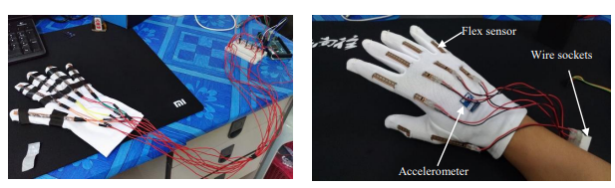

*1.2 Glove Mechanism*

**Hardware Components and Circuit Design:**

The glove-based sign language translation device consists of input sensors (flex sensors and an accelerometer) and output components (LCD display), all connected to an Arduino microcontroller. Flex sensors measure finger bending angles, while the accelerometer detects hand movements on three axes. The Arduino processes sensor data using a gesture recognition algorithm, displaying the translation on an LCD screen.

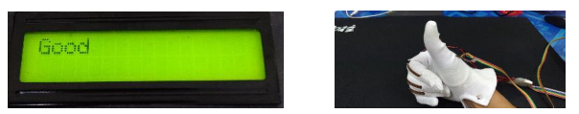

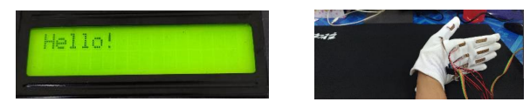

*1.3 Working of Glove Mechanism*

**Development of the Prototype:**

Initial prototypes involved attaching flex sensors to gloves using tapes, which proved cumbersome and prone to sensor displacement. Subsequent designs incorporated sewn-on sensors for better stability and mobility. A printed circuit board (PCB) was introduced to ensure reliable connections between sensors and the microcontroller, while a main box housed all components for ease of use.

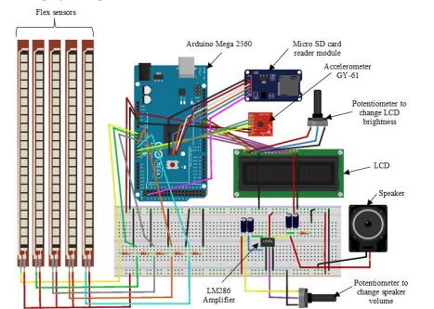

*1.4 Hardware component of Glove Approach*

The glove-based sign language translation device offers a promising solution for facilitating communication between deaf individuals and the general public. Through innovative hardware design and preliminary testing, the device demonstrates reliable performance in recognizing and translating sign language gestures. Future developments aim to enhance the device's usability by implementing wireless connectivity, further improving accessibility for deaf communities.

### Computer Vision-Based Approach

### Computer Vision-based approaches leverage cameras and computer vision techniques to recognize sign language gestures directly from visual input. By analyzing the movements and configurations of the hands and other relevant body parts, these systems can interpret sign language gestures without the need for specialized hardware. Vision based approaches are more versatile and accessible, as they can be implemented using widely available devices such as smartphones or webcams. Additionally, they offer a more natural interaction experience, as users are not encumbered by wearable sensors. As a result, vision-based approaches are often preferred by sign language users for their ease of use and flexibility.

### 

### *1.5 Process of Computer Vision*

### Image Acquisition:

### Utilizing a webcam as the hardware-based source to capture images, which serve as input for subsequent processing stages.

### 

### *1.6 Image Acquisition*

### Segmentation:

### The process of separating hand gestures from the background using various techniques, including context subtraction, skin-color detection, and edge detection.

### The objective is to detect and segment the motion and location of the hand to facilitate gesture recognition.

### 

### *1.7 Image Segmentation*

### 

### Feature Extraction:

### Extracting predefined features such as form, contour, color, and histogram from preprocessed images.

### Feature extraction aids in reducing the dimensionality of the data, making processing simpler, and selecting the best features from large datasets.

### 

### *1.8 Feature Extraction*

### Preprocessing:

### Preprocessing involves several steps to reduce noise in the images and prepare them for further analysis.

### Morphological transformations, including erosion and dilation, are applied to the images to enhance visibility and fill in small gaps.

### Thresholding is utilized to convert grayscale images into binary images, simplifying interpretation and focusing on areas of interest.

### 

### *1.9 Mechanism of Preprocessing*

### 

### Proposed Algorithm

**1**. **Input Image Acquisition**:

- Capture input images using a webcam or any other image source.

**2**. **Preprocessing:**

- Preprocess the input images to enhance quality and reduce noise.

- Apply techniques like morphological transformations, blurring, and thresholding to improve image clarity.

**3**. **Sign Language Detection with YOLOv5x:**

- Utilize the YOLOv5x model for real-time Sign Language detection.

- The YOLOv5x model processes the entire image in one pass, identifying objects swiftly.

- Extract hierarchical features from the image using convolutional layers and max-pooling layers.

- Predict bounding boxes and class probabilities directly from the feature map generated by the CNN.

**4**. **Integration of Attention Mechanisms (SE and CBAM**):

- Incorporate Squeeze-and-Excitation (SE) and Convolutional Block Attention Module (CBAM) into the YOLOv5x model.

- SE module: Model correlations between different channels to select pertinent characteristics and suppress less reliable ones.

- CBAM module: Combine spatial and channel attention mechanisms to identify crucial properties in three dimensions.

**5. Gesture Recognition:**

- Focus on hand gesture detection within the detected objects.

- Utilize the enhanced feature representation and refined detection capabilities from SE and CBAM modules.

**6**. **Classification with CNN**:

- Apply a Convolutional Neural Network (CNN) architecture for gesture classification.

- The CNN architecture comprises multiple convolutional and dense layers.

- Extract features from the preprocessed images using convolutional layers.

- Utilize attention mechanisms within the CNN to focus on relevant features and improve accuracy.

- Classify the hand gestures into respective categories of the Indian Sign Language (ISL) signs.

**7. Output and Evaluation:**

- Output the recognized gestures along with their corresponding classifications.

- Evaluate the performance metrics, including precision, recall, mean Average Precision (mAP), and F1 score.

8. **Validation and Testing:**

- Validate and test the model using benchmark datasets like the MU HandImages Indian Sign Language (ISL) dataset.

- Assess the recognition rates and accuracy of the model on diverse datasets.

**9. Comparison with Existing Models:**

- Compare the performance of the proposed model with existing systems, including previous iterations of YOLO and other gesture recognition models.

- Evaluate precision, recall, mAP, and F1 score to demonstrate the superiority of the proposed model.

**10. Ongoing Development:**

- Plan for further refinement of the model, focusing on reducing tuning parameters and exploring diverse application scenarios.

- Commit to continuous development to enhance performance and versatility, ensuring the model remains at the forefront of real-time gesture detection technology.

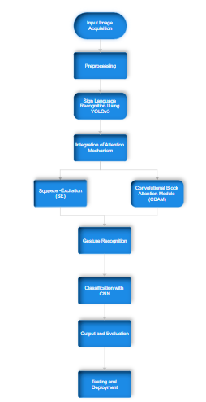

* 1. *Flow Chart of Proposed Algorithm*

### 1.6 Proposed System

The proposed model integrates YOLOv5x with SE and CBAM attention modules for sign language recognition. It starts by acquiring input images, preprocesses them, and then uses YOLOv5x for object detection. Attention mechanisms like SE and CBAM are integrated to enhance feature representation. The model focuses on gesture recognition and classification using a CNN architecture, outputting recognized gestures and evaluating performance metrics. Validation is done using benchmark datasets, and comparisons are made with existing models. Ultimately, the model can be deployed on edge-based platforms for real-world applications, with ongoing development for further refinement and exploration.

CHAPTER-2

# LITERATURE SURVEY

### Introduction to Literature Survey

A literature survey for Indian Sign Language Recognition involves in identifying the patterns of the image and detects the sign language based on the hand signatures. The main objective is to analyze the data (Images) and list out the data by predicting them based on the training data. The literature survey deals with multiple steps like identifying the research question analyzing the data, taking required information, and understanding multiple approaches used in this topic. A literature survey helps us to identify the gaps which will help in filling them.

### Literature Survey

**1.A. L. C. Barczak, N. H. Reyes, M. Abastillas, A. Piccio, and T. Susnjak, “A new 2d static hand gesture colour image dataset for asl gestures,” Research Letters in the Information and Mathematical Sciences, vol. 15, pp. 12–20, 2011.**

The images were acquired as follows: volunteers gesticulated standard ASL gestures close to acamera on a tripod, with a neutral-coloured wall behind the subject, and a green backgroundbehind the hands. To add variety to the illumination conditions, a series of mounted lamps wereused, from top, bottom, left and right. Diﬀuse lighting conditions were achieved with lampsfrom various directions, simulating a natural environment. Figure 1 shows the image acquisitionapproach.In order to facilitate the segmentation process, the person taking the images for the training setwas asked to wear a wrist cover with the same background colour (see ﬁgure 2). Once the handsare segmented, they can be used for training directly. If the experiment requires separate trainingand test sets, it is possible to split them and add artiﬁcial backgrounds to the hand images.The images are furnished with the best colour segmentation on a black background (i.e., witha (R=0,G=0,B=0) background)

#### 2. J. Redmon, S. Divvala, R. Girshick, and A. Farhadi, “You only look once: Unified, real-time object detection,” in Proceedings of the IEEE conference on computer vision and pattern recognition, 2016, pp. 779– 788.

A new approach to object detection. Prior work on object detection repurposes classifiers to perform detection. Instead, we frame object detection as a regression problem to spatially separated bounding boxes and associated class probabilities. A single neural network predicts bounding boxes and class probabilities directly from full images in one evaluation. Since the whole detection pipeline is a single network, it can be optimized end-to-end directly on detection performance. Our unified architecture is extremely fast.The base YOLO model processes images in real-time at 45 frames per second. A smaller version of the network, Fast YOLO, processes an astounding 155 frames per second while still achieving double the mAP of other real-time detectors. Compared to state-of-the-art detection systems, YOLO makes more localization errors but is less likely to predict false positives on background. Finally, YOLO learns very general representations of objects. It outperforms other detection methods, including DPM and R-CNN, when generalizing from natural images to other domains like artwork

#### 3. H.-D. Yang, “Sign language recognition with the kinect sensor based on conditional random fields,” Sensors, vol. 15, no. 1, pp. 135–147, 2015.

Sign language is a visual language used by deaf people. One difficulty of sign language recognition is that sign instances of vary in both motion and shape in three-dimensional (3D) space. In this research, we use 3D depth information from hand motions, generated from Microsoft's Kinect sensor and apply a hierarchical conditional random field (CRF) that recognizes hand signs from the hand motions. The proposed method uses a hierarchical CRF to detect candidate segments of signs using hand motions, and then a BoostMap embedding method to verify the hand shapes of the segmented signs.

#### 4 .L. Pigou, S. Dieleman, P.-J. Kindermans, and B. Schrauwen, “Sign language recognition using convolutional neural networks,” in European Conference on Computer Vision. Springer, 2014, pp. 572–578

The data set from the ChaLearn Looking at People 2014 [5] (CLAP14) challenge in this work. More specifically, Track 3: Gesture Spotting. This dataset consists of 20 different Italian gestures, performed by 27 users with variations in surroundings, clothing, lighting and gesture movement. The videos are recorded with a Microsoft Kinect. As a result, we have access to the depth map, user index (location of the user in the depth map) and the joint positions (Figure 1). 574 L. Pigou et al. We use 6600 gestures in the development set of CLAP14 for our experiments: 4600 for the training set and 2000 for the validation set. The test set of CLAP14 is also considered as the test set for this work and consists of 3543 samples. The users and backgrounds in the validation set are not contained in the training set. The users and backgrounds in the test set can occur in the training and the validation set.

**5. A. Bochkovskiy, C.-Y. Wang, and H.-Y. M. Liao, “Yolov4: Optimal speed and accuracy of object detection,” arXiv preprint arXiv:2004.10934, 2020**

There are a huge number of features which are said to improve Convolutional Neural Network (CNN) accuracy. Practical testing of combinations of such features on large datasets, and theoretical justification of the result, is required. Some features operate on certain models exclusively and for certain problems exclusively, or only for small-scale datasets; while some features, such as batch-normalization and residual-connections, are applicable to the majority of models, tasks, and datasets. We assume that such universal features include Weighted-Residual-Connections (WRC), Cross-Stage-Partial-connections (CSP), Cross mini-Batch Normalization (CmBN), Self-adversarial-training (SAT) and Mish-activation. We use new features: WRC, CSP, CmBN, SAT, Mish activation, Mosaic data augmentation, CmBN, DropBlock regularization, and CIoU loss, and combine some of them to achieve state-of-the-art results: 43.5% AP (65.7% AP50) for the MS COCO dataset at a realtime speed of ~65 FPS on Tesla V100.

CHAPTER-3

# SYSTEM ANALYSIS

### Introduction

The communication challenges faced by marginalized groups, particularly the deaf community, highlighting the necessity for inclusive solutions. It introduces YOLO (You Only Look Once) as a pioneering system grounded in Convolutional Neural Networks (CNNs), poised to revolutionize sign language recognition. Attention mechanisms within CNN architectures are discussed for their potential to augment performance in computer vision tasks. The proposal advocates for integrating these mechanisms seamlessly into the YOLOv5 framework to enhance various aspects of sign language recognition. By leveraging attention mechanisms, the research aims to break down communication barriers and empower the deaf community, fostering a more inclusive future. Additionally, the discussion explores the benefits of attention mechanisms in improving recognition accuracy and efficiency, particularly in Indian Sign Language (ISL) recognition. This integration holds promise for advancing sign language recognition technology and promoting more inclusive communication and interaction.

### Problem Statement

Despite advancements in technology, individuals with disabilities, particularly the deaf community, continue to face communication barriers, hindering their integration into society. Traditional methods of sign language interpretation often rely on human intermediaries, leading to delays and limitations in communication effectiveness. Existing automated sign language recognition systems exhibit deficiencies in real-time processing, precision, and adaptability to diverse contexts. Moreover, these systems often lack attention mechanisms that are crucial for accurately identifying and interpreting sign language gestures, especially in complex or dynamic environments. Therefore, there is a pressing need for a robust and efficient technological solution that can bridge the communication gap between hearing and deaf individuals, empowering the latter with seamless access to information and fostering inclusivity in various social settings.

### Existing System

In the existing system, the primary focus is on addressing the challenge of recognizing Indian Sign Language (ISL), given its vital importance for individuals with speech impairments. Despite the substantial population affected by speech impairment in India, limited research has been conducted in this area, highlighting the need for robust solutions. The complexities inherent in ISL, including variations in signs across regions and the absence of standardized datasets, pose significant obstacles to effective recognition. To tackle these challenges, the proposed methodology leverages deep learning technologies, particularly Convolutional Neural Networks (CNNs), which have demonstrated remarkable advancements in image recognition tasks. The approach involves utilizing a Bag of Visual Words (BOVW) model with Speeded-Up Robust Features (SURF) for feature extraction, aiming to capture the unique characteristics of ISL gestures. Furthermore, strategies such as background segmentation and skin color-based methods are employed to mitigate issues related to background dependency.

Classification tasks are handled using Support Vector Machine (SVM) with a linear kernel and CNN models. The SVM is trained on histograms of visual words extracted from the images, while the CNN utilizes convolutional layers to learn hierarchical features directly from the data. A custom dataset is created by capturing images with varying backgrounds and rotations, ensuring diversity and robustness in training. Performance evaluation measures, including accuracy, precision, recall, and F1 score, are employed to assess the effectiveness of the proposed approach

This comprehensive evaluation provides insights into the efficacy of the system in accurately recognizing and interpreting ISL gestures, thereby offering a promising solution to enhance communication accessibility for individuals with speech impairments. Ultimately, the successful implementation and validation of the proposed methodology hold profound implications for the field of assistive technology and accessibility. By empowering speech-impaired individuals with robust and accurate ISL recognition systems, researchers aspire to enhance their communication capabilities and promote inclusivity in all facets of society. This advancement not only facilitates smoother communication between individuals with speech impairments and their peers but also fosters greater integration and participation in educational, professional, and social settings. As such, the culmination of this research endeavor represents a significant step towards realizing the overarching goal of creating a more equitable and inclusive society for all individuals, regardless of their communication abilities.

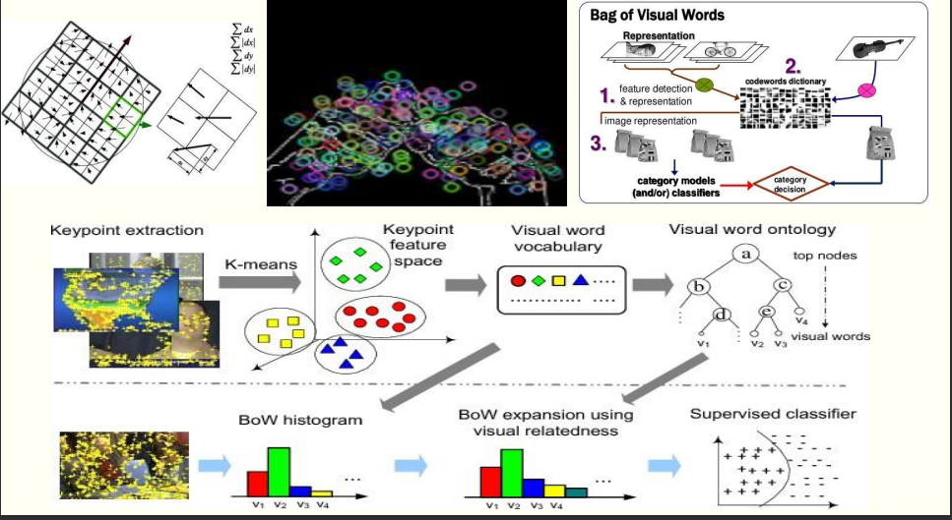

*3.1 Mechanism of Existing System*

### 3.4 Modules Description

**1**. **Utilization of YOLO-based Deep Learning Models**

- Integration of YOLOv5x with attention algorithms like Squeeze-and-Excitation (SE) and Convolutional Block Attention Module (CBAM) for real-time object detection, specifically in sign language recognition.

- YOLOv5x celebrated for its heightened speed and accuracy compared to previous versions, making it suitable for rapid processing applications.

- Incorporation of attention mechanisms like SE and CBAM enhances feature representation and improves detection and recognition of hand gestures.

**2. Performance Metrics and Training Methodologies**

- YOLOv5x models with attention modules demonstrate superior precision, recall, mean Average Precision (mAP), and F1 score compared to standalone YOLOv5x.

- Training methodologies incorporate transfer learning and augmentation techniques to enhance model robustness and generalization across diverse datasets.

**3. Deployment and Integration**

- Lightweight nature of models and optimized real-time performance enable deployment on edge-based platforms such as smartphones and wearable devices.

- Integration into assistive technologies aids individuals with hearing impairments, promoting inclusivity in real-world scenarios.

**4. Comparative Analysis and Recognition Rates**

- Comparative analyses demonstrate superiority of proposed models over existing systems in precision, recall, mAP, and F1 score, affirming potential for real-time gesture detection applications.

- Significantly higher recognition rates achieved on the MU HandImages Indian Sign Language Dataset (ISL) compared to existing models, indicating reliability in recognizing sign language gestures.

**5. Future Refinement and Development**

- Plans for further refinement focus on reducing tuning parameters and exploring diverse application scenarios, ensuring continuous enhancement of performance and versatility in real-time gesture detection technology.

CHAPTER-4

# SYSTEM REQUIREMENTS

### Software Requirements

* Operating System: Linux, Windows, macOS
* Server-side Script: Python 3.x
* IDE: Jupyter Notebook, Google Colab (optional)
* Libraries Used: PyTorch, tqdm, sklearn

**4.2 Hardware Requirements**

* Processor: Intel Core i5 or equivalent
* RAM: 8GB or higher
* Hard Disk: 128GB or higher
* GPU (optional, for faster training with CUDA support)

**4.3 Project Prerequisites**

* Python Programming Skills
* Deep Learning Knowledge
* PyTorch Framework
* Knowledge of Torchvision library
* Image processing knowledge
* Tensorboard (optional, for visualization)
* Internet Connectivity (for downloading datasets and models)
* Webcam (optional, for testing the detection model on live video)
* Image Display Device (for visualizing results)
* Computer or Server with sufficient resources for training and inference

The software requirements include a compatible operating system (Linux, Windows, or macOS), Python 3.x as the server-side script, and Jupyter Notebook or Google Colab as the integrated development environment (IDE). Additionally, the required libraries are PyTorch for deep learning, tqdm for progress tracking, and sklearn for calculating accuracy metrics.

Hardware requirements involve an Intel Core i5 processor or equivalent, at least 8GB of RAM, and a minimum of 128GB of hard disk space. Optionally, a GPU with CUDA support can be utilized for faster training.

Project prerequisites encompass proficiency in Python programming, knowledge of deep learning concepts, particularly PyTorch framework, and Torchvision library for computer vision tasks. Familiarity with image processing techniques is also essential. Additionally, Tensorboard can be used for visualization, internet connectivity is needed for data and model downloading, and a webcam and image display device are optional for testing and result visualization. Finally, a computer or server with sufficient resources for training and inference is necessary.

**Python Programming Skills:**

- Python is the primary programming language used for implementing machine learning and deep learning algorithms.

- Proficiency in Python enables developers to write clean, efficient, and maintainable code for data preprocessing, model training, and evaluation.

**Deep Learning Knowledge:**

- Deep learning is a subset of machine learning that deals with neural networks having multiple layers.

- Understanding deep learning concepts such as neural network architectures, optimization algorithms, and loss functions is crucial for designing and training effective models.

**PyTorch Framework:**

- PyTorch is a popular open-source deep learning framework developed by Facebook's AI Research lab.

- It provides a flexible and dynamic computational graph, making it easier to define and train complex neural network models.

- Knowledge of PyTorch allows developers to leverage its extensive library of pre-built modules and utilities for building custom deep learning models.

**Knowledge of Torchvision Library:**

- Torchvision is a part of the PyTorch ecosystem specifically designed for computer vision tasks.

- It provides various utilities for data loading, image transformation, and model evaluation, making it easier to work with image datasets.

- Understanding Torchvision is essential for preprocessing image data and evaluating model performance on image-based tasks.

**Image Processing Knowledge:**

- Image processing involves techniques for manipulating and analyzing digital images.

- Knowledge of image processing techniques such as edge detection, feature extraction, and noise reduction is essential for preprocessing image data before feeding it into the deep learning model.

**Tensorboard (optional, for visualization):**

- Tensorboard is a visualization tool provided by TensorFlow for monitoring and visualizing deep learning experiments.

- While optional, Tensorboard can be useful for visualizing model training metrics, comparing different experiments, and debugging model performance.

**Internet Connectivity (for downloading datasets and models):**

- Internet connectivity is necessary for downloading datasets and pre-trained models required for training and testing the deep learning model.

- Access to online resources allows developers to leverage publicly available datasets and models, saving time and effort in data collection and model development.

**Webcam (optional, for testing the detection model on live video):**

- A webcam can be used for real-time testing and evaluation of the trained detection model on live video streams.

- While optional, a webcam enables developers to assess the model's performance in real-world scenarios and make necessary adjustments for better accuracy.

**Image Display Device (for visualizing results):**

- An image display device, such as a computer monitor or screen, is essential for visualizing the results of the detection model.

- It allows developers to view the detected objects, bounding boxes, and confidence scores generated by the model for different images or video frames.

**Computer or Server with sufficient resources for training and inference:**

- A computer or server with sufficient computational resources, including CPU, GPU (optional but recommended for faster training), and memory (RAM), is necessary for training and inference of deep learning models.

- Adequate resources ensure smooth execution of training algorithms and efficient inference during model deployment, leading to faster experimentation and improved model performance.

CHAPTER-5

# SYSTEM DESIGN

### Introduction

### The proposed system addresses the need for real-time object detection, particularly in sign language recognition, by integrating YOLOv5x with attention mechanisms like SE and CBAM. Leveraging YOLO techniques, the models swiftly detect objects, ideal for applications requiring rapid processing. Performance metrics indicate superior precision, recall, mAP, and F1 score compared to standalone YOLOv5x, enhancing detection and classification of hand gestures. Transfer learning and augmentation techniques fortify model robustness, mitigating overfitting and improving generalization across datasets. Lightweight models allow deployment on edge-based platforms, aiding assistive technologies for individuals with hearing impairments. Comparative analyses affirm the models' superiority in precision, recall, and recognition rates on ISL datasets, crucial for effective communication. Despite their advanced capabilities, the models maintain efficiency in resource usage, suitable for deployment on resource-constrained platforms. Future refinement aims to reduce tuning parameters and explore diverse application scenarios, ensuring continuous enhancement in performance and versatility, advancing real-time gesture detection technology.

### System Model

#### YOLO MODEL:

#### The YOLO (You Only Look Once) model is a CNN-based object detection system renowned for its rapid and accurate identification of objects in images. YOLOv5, an evolution of this technique, offers compact size and swift inference on real-time feeds, making it ideal for various applications. Its architecture includes input preprocessing, multi-scale feature extraction, and integration phases, culminating in efficient object detection. YOLO processes entire images in one pass, leveraging convolutional neural networks (CNNs) to extract hierarchical features crucial for recognition. Availability in popular frameworks like TensorFlow and PyTorch, along with open-source repositories, simplifies integration and customization for diverse applications. YOLO's versatility extends to domains such as autonomous driving, surveillance, object tracking, and robotics, showcasing its effectiveness in various object detection tasks.

#### Convolutional neural network(CNN):

#### CNNs are functional extraction models inspired by the human brain’s visual cortex. CNNs compare images piece by piece where a filter map slides over the local patches of the image. Such pieces are called features, and they compare two images by finding approximately the same features at approximately the same locations. CNNs have a better ability to see images and classify them than other neural networks. Our general architecture is a fairly common CNN architecture, consisting of multiple convolutional and dense layers. Each CNN is 3 layers deep. The architecture starts with a group of 2 convolutional layers which have 32 filters with a window size of 3 × 3 followed by a maxpool layer and a dropout layer. It is then followed by another group of 2 convolutional layers with 64 filters, a max pooling layer and dropout layer. Further, there are another 2 convolutional layers with 64 filters and a max pooling layer and at the end, there is a fully connected hidden layer with 512 neurons of the ReLU activation function and an output layer of the softmax activation function. The first convolution layer takes an input image of size (100,100) whereas the final output layer consists of 36 neurons corresponding to each category of the ISL signs

### System Architecture

### 

### *5.1 Model Architecture*

The process begins with acquiring input images from a webcam or other sources, followed by preprocessing to enhance quality and reduce noise through techniques like morphological transformations and blurring. Utilizing the YOLOv5x model, real-time object detection is performed by processing the entire image in one pass, extracting hierarchical features, and predicting bounding boxes and class probabilities directly. Integration of attention mechanisms like Squeeze-and-Excitation (SE) and Convolutional Block Attention Module (CBAM) enhances feature representation and detection capabilities. Hand gesture detection is then focused on within the detected objects, followed by classification using a Convolutional Neural Network (CNN) architecture with attention mechanisms to improve accuracy. Finally, the recognized gestures are outputted along with their classifications, and the model's performance is evaluated using metrics like precision, recall, mAP, and F1 score, validated on benchmark datasets like the MU HandImages Indian Sign Language (ISL) dataset. Comparisons with existing models highlight the superiority of the proposed model, which can be deployed on edge-based platforms for real-world applications, with ongoing development focused on further refinement and exploration of diverse scenarios.

### YOLOv5 Architecture

### YOLOv5 consists of three main components in its network topology: -

### Input Phase: Image preprocessing procedures, including augmentation and scaling of the input image.

### Backbone Network: A deep convolutional neural network that gathers and creates image features at various scales, comprising modules like Focus, Conv, C3, and SPP.

### Neck Network: Integrates and mixes picture features, expanding the range of features, consisting mostly of Conv, upsampling, and C3 modules.

### Head Output Phase: Builds item bounding boxes, classifies object classes, and predicts outcomes. Classification.

# YOLOv5: Overall Architecture

* (YOLOv5 is explained in a paper: **2022 MDPI J. Sensors**, [**SF-YOLOv5: A Lightweight Small Object Detection Algorithm Based on Improved Feature Fusion Mode**](https://www.mdpi.com/1424-8220/22/15/5817).)

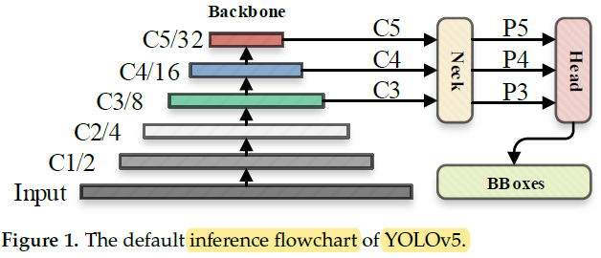

*5.2 Flowchart of Yolov5*

**YOLOv5: Overall Architecture**

* The image was processed through a**input layer (input)** and sent to the **backbone for feature extraction**.
* The backbone obtains feature maps of different sizes, and then fuses these features through the **feature fusion network (neck)** to finally **generate three feature maps P3, P4, and P5** (in the YOLOv5, the dimensions are expressed with the size of 80×80, 40×40 and 20×20) to **detect small, medium, and large objects** in the picture, respectively.
* After the three feature maps were **sent to the prediction head (head)**, the **confidence calculation**and**bounding-box regression** were executed for each pixel in the feature map using the preset prior anchor, so as to obtain a multi-dimensional array (BBoxes) including object class, class confidence, box coordinates, width, and height information.
* **By setting the corresponding thresholds (confthreshold, objthreshold)** to filter the useless information in the array, and performing a **non-maximum suppression (NMS) process**, the **final detection information can be output.**

# YOLOv5: Backbone

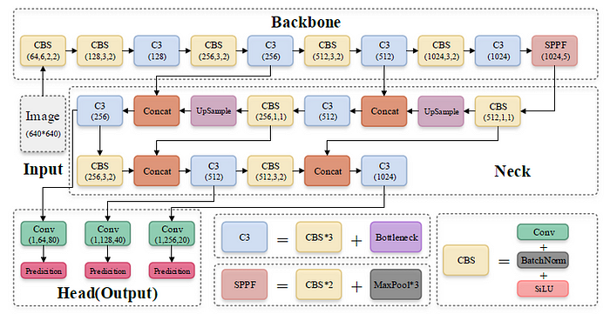

*5.3 Backbone of Yolov5*

**YOLOv5: Model Architecture**

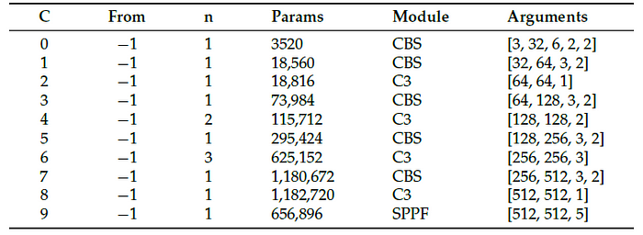

**Parameters of YOLOv5 Backbone**

* The backbone is [**CSP**](https://sh-tsang.medium.com/review-cspnet-a-new-backbone-that-can-enhance-learning-capability-of-cnn-da7ca51524bf)**Darknet53**.
* The main structure is the **stacking of multiple CBS (Conv +**[**BatchNorm**](https://sh-tsang.medium.com/review-batch-normalization-inception-v2-bn-inception-the-2nd-to-surpass-human-level-18e2d0f56651)**+**[**SiLU**](https://sh-tsang.medium.com/review-silu-sigmoid-weighted-linear-unit-be4bc943624d)**) modules and**[**C3 module**](https://sh-tsang.medium.com/reading-c3-concentrated-comprehensive-convolution-semantic-segmentation-5b6dd3fb46b2)**s**, and**finally one SPPF module** is connected.
* **CBS module is used to assist**[**C3 module**](https://sh-tsang.medium.com/reading-c3-concentrated-comprehensive-convolution-semantic-segmentation-5b6dd3fb46b2)**in feature extraction**, while **SPPF module enhances the feature expression ability of the backbone.**

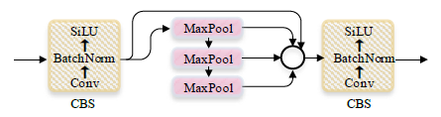

**Structure of SPPF**

* **SPPF avoided the repeated operation of**[**SPP**](https://medium.com/coinmonks/review-sppnet-1st-runner-up-object-detection-2nd-runner-up-image-classification-in-ilsvrc-906da3753679)**as in**[**SPPNet**](https://medium.com/coinmonks/review-sppnet-1st-runner-up-object-detection-2nd-runner-up-image-classification-in-ilsvrc-906da3753679)**, by max pooling the previous max pooled features.**
* This can **significantly improved the running speed** of the module.

# YOLOv5: Neck

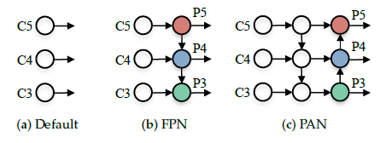

**(a) Without Feature Fusion, (b)**[**FPN**](https://towardsdatascience.com/review-fpn-feature-pyramid-network-object-detection-262fc7482610)**and (c)**[**PAN**](https://sh-tsang.medium.com/review-pan-pyramid-attention-network-for-semantic-segmentation-semantic-segmentation-8d94101ba24a).

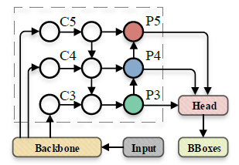

*5.4 Neck of Yolov5*

**YOLOv5: Neck**(Within Dashed Box)

YOLOv5 uses the methods of [**FPN**](https://towardsdatascience.com/review-fpn-feature-pyramid-network-object-detection-262fc7482610)**and**[**PAN**](https://sh-tsang.medium.com/review-pan-pyramid-attention-network-for-semantic-segmentation-semantic-segmentation-8d94101ba24a).

The basic idea of [FPN](https://towardsdatascience.com/review-fpn-feature-pyramid-network-object-detection-262fc7482610) is to **up-sampling the output feature map (C3, C4, and C5) generated by multiple convolution down sampling operations from the feature extraction network to generate multiple new feature maps (P3, P4, and P5)**for detecting different scales targets.

# 4. YOLOv5: Head

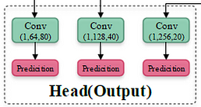

*5.5 Head of Yolov5*

**YOLOv5: Head**

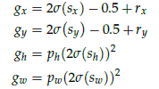

**Bounding Box Regression**

* The coordinate value of the upper left corner of the feature map is set to (0, 0).
* **rx and ry** are the **unadjusted coordinates**of the **predicted center point.**
* **gx, gy, gw, gh**represent the information of the**adjusted prediction box.**
* **pw**and **ph**are for the information of the **prior anchor.**
* **sx**and **sy**represent the **offsets calculated by the model.**

The process of **adjusting the center coordinate** and**size of the preset prior anchor** to the center coordinate and size of the final prediction box.

# ****5. YOLOv5: Model Variants****

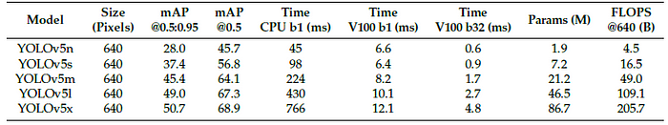

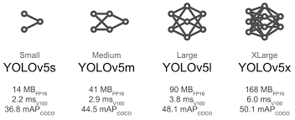

* 1. *Different Versions of Yolov5*

There are **5 versions of YOLOv5**, namely YOLOv5x, YOLOv5l, YOLOv5m, YOLOv5s, and YOLOv5n.

There are also **5 corresponding larger versions**, **YOLOv5x6, YOLOv5l6, YOLOv5m6, YOLOv5s6, and YOLOv5n6.**

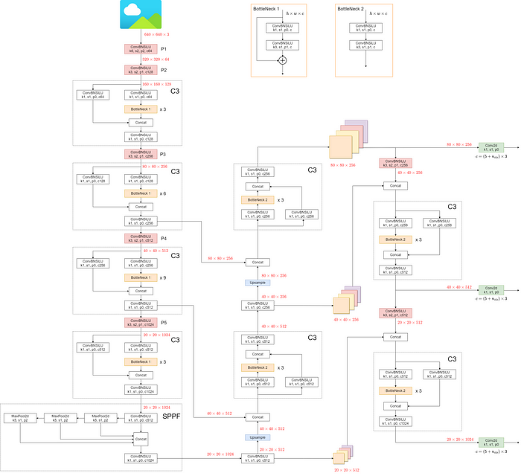

***5.7 Mechanism of Yolov5***

**YOLOv5l: Detailed Architecture**(<https://docs.ultralytics.com/yolov5/tutorials/architecture_description/#2-data-augmentation>)

### C3 Module

The original module used in YOLOv5, which contains a CSP connection and N 3*3 convolutional layers, and fuses the two feature paths using concat and integrates the features through the final 1*1 convolutional layer. Right. C3AT module: We use the AFE module in the C3 module to replace the original 3*3 convolutional layers, and then add an attention mechanism after concat to process the multi-scale contextual feature information extracted by the AFE module

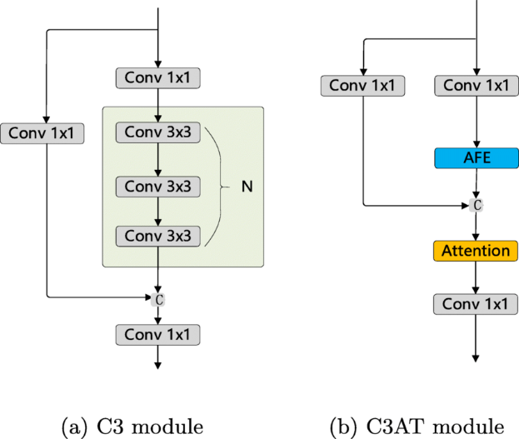

*5.8 C3 Module*

### CBS Module

The basic component of the backbone network of YOLOv5 is the CBS module, which is a convolution–BatchNorm–SiLu activation function sequence superposition module. These basic components are stacked together, and C3 modules are inserted in the middle. A C3 module is a combination of CBS blocks under the guidance of a CSPNet design. Through the stacking of C3 blocks and CBS blocks, the backbone continuously learns the features of higher dimensions. At the deepest level of the network, YOLOv5 features an SPPF module, which can be regarded as an optimized and faster spatial pyramid pooling (SPP) operation. It converts a feature image of any size into a feature vector of a fixed size, so that the input size of the network no longer needs to be fixed, thus realizing the fusion of local and global features.

### CSPDarknet

CSPDarknet53 improves on DarkNet-53 by using a new approach called Cross Stage Partial Network (CSPNet). This approach uses a split and merge strategy to improve the flow of gradients through the network. This helps to improve the accuracy of the system by allowing it to learn more complex representations of the input data.

The split and merge strategy used by CSPDarknet53 allows the system to divide the input data into smaller sections that are easier to process. It then uses cross-stage connections to combine these sections back into a larger representation of the input data. This approach improves the accuracy of the network while reducing the amount of RAM required to store the intermediate representations of the input data.

### 

*5.9 Darknet53*

### 5.4.4 SPP and SPPF Module

In the backbone network of YOLOv5s, the spatial pyramid pooling fast module is located in the last layer. Its combination of multiple small-sized pooling layers replaces the single large-sized pooling layers in the SPP module. Therefore, while retaining fusing feature maps of different receptive fields and enriching the expressive ability of feature maps, the running speed is further improved. The structure of the SPPF module. The module first uses a 1 × 1 convolution operation, then uses three maxpooling layers with a window size of 5 to extract features with different receptive fields. Then, these four processed features will be fused and processed for channel number through a 1 × 1 convolution. At the beginning of the design of the SPPF module, it was believed that aggregating information from the previous layers that had already been deeply processed may be more in line with the human brain’s cognitive process of objects when processing objects of different scales at deeper layers. We revisit this view when the feature information of the object passes through multiple feature extraction layers, its feature map has been reduced to 1/32 of the original, the feature information contained is relatively little, and the feature information already belongs to relatively high-level abstract information, on this basis, using the SPPF module to fuse the feature information of multiple receptive fields may not bring the expected effect. Therefore, we propose a multi-path spatial pyramid feature fusion structure. Using spatial pyramid pooling module to extract multi-scale features from each down-sampled feature map and pass them to deeper layers of the network.

Our experimental results show that for large feature maps, a larger receptive field should be used when using spatial pyramid pooling after different scale feature maps. Based on this idea, we replace the max pooling layers in the SPPF module with the Rep Conv module with a larger receptive field, which can avoid the disadvantage of information loss caused by the pooling operation itself. In addition, Rep Conv can implement larger kernels without incurring excessive memory computation costs. Therefore, it is possible to directly design and construct the RepLK-SPP module according to the parallel architecture of the SPP module without the need for grouping stacking with a small field of view, such as the SPPF module. 3, x FOR PEER REVIEW 11 of 21 feature maps, a larger

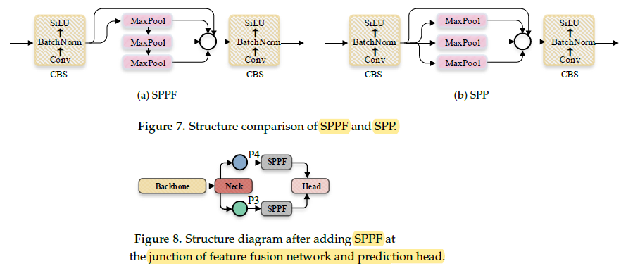

*5.10 SPPF & SPP Architecture*

receptive field should be used when using spatial pyramid pooling after different scale feature maps. Based on this idea, we replace the max pooling layers in the SPPF module with the Rep Conv module with a larger receptive field, which can avoid the disadvantage of information loss caused by the pooling operation itself.

In addition, Rep Conv can implement larger kernels without incurring excessive memory computation costs. Therefore, it is possible to directly design and construct the RepLK-SPP module according to the parallel architecture of the SPP module without the need for grouping stacking with a small field of view, such as the SPPF module, as shown in Figure 5b. Figure 5. Illustration of the RepLK-SPP module: (a) SPPF module; (b) RepLK-SPP module. As shown in Figure 6, in the multi-path spatial pyramid feature fusion structure designed in this paper, the same down-sampled feature map will be processed separately by the RepLK-C3 module and the RepLK-SPP module. Additionally, we use the same kernel size design for feature maps of the same size, with the kernel size changing as the feature map scale changes, in order to achieve the best perception field. We visualized the feature maps of the CBS module of the third down-sampling, the Rep-C3 module, the Rep-SPP module in the subsequent branch, and the corresponding position of the C3 module in the original YOLOv5. It can be seen from (III and IV) that compared with the C3 module, the RepLK-C3 module proposed in this paper can filter irrelevant texture information and highlight shape information while retaining more detailed information; From (V), it can be seen that the proposed RepLK-SPP module can greatly highlight the position information of the image, especially for defect types, such as crazing, pitted surface, and rolled-in scale that contain a large amount of complex background interference.

In the original feature fusion path design, the feature map after the feature extraction of the C3 module will be sent to the subsequent network. However, for the processing of complex textures on the steel surface, the C3 module is not very competent, which will bring poor results to the subsequent feature fusion. Therefore, by using a branch design to extract shape and position information separately using the RepLK-C3 Figure 5. Illustration of the RepLK-SPP module: (a) SPPF module; (b) RepLK-SPP module. in the multi-path spatial pyramid feature fusion structure designed in this paper, the same down-sampled feature map will be processed separately by the RepLK-C3 module and the RepLK-SPP module. Additionally, we use the same kernel size design for feature maps of the same size, with the kernel size changing as the feature map scale changes, in order to achieve the best perception field. We visualized the feature maps of the CBS module of the third down-sampling, the Rep-C3 module, the Rep-SPP module in the subsequent branch, and the corresponding position of the C3 module in the original YOLOv5. The results are shown in Figure 7. It can be seen from (III and IV) that compared with the C3 module, the RepLK-C3 module proposed in this paper can filter irrelevant texture information and highlight shape information while retaining more detailed information; From (V), it can be seen that the proposed RepLK-SPP module can greatly highlight the position information of the image, especially for defect types, such as crazing, pitted surface, and rolled-in scale that contain a large amount of complex background interference. In the original feature fusion path design, the feature map after the feature extraction of the C3 module will be sent to the subsequent network. However, for the processing of complex textures on the steel surface, the C3 module is not Sensors 2023, 23, 5114 11 of 20 very competent, which will bring poor results to the subsequent feature fusion. Therefore, by using a branch design to extract shape and position information separately using the RepLK-C3 module and RepLK-SPP module on each scale feature map, significant effects can be achieved.

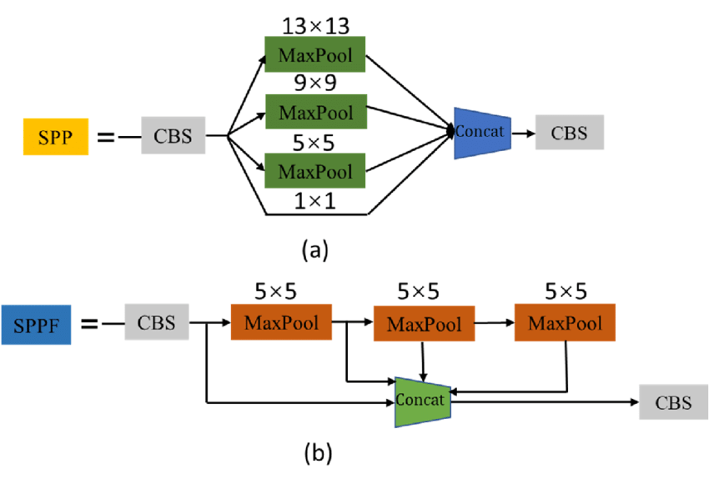

*5.11 RepLK-SPP module*

**5.4.5 Feature Pyramid Network (FPN)**

The architecture of YOLOv5 follows a similar concept to previous versions of YOLO, where a single neural network is trained to directly predict bounding boxes and class probabilities for each object in the image. However, YOLOv5 has undergone several improvements to make it faster and more accurate. The network architecture of YOLOv5 is based on a backbone of CSP convolutional layers and a neck of PAN layers, followed by three different-sized detection heads. This architecture allows the model to capture features at different scales, leading to improved accuracy in object detection tasks.

The basic idea behind an FPN is to construct a pyramid of multi-scale feature maps from a single input image. This pyramid is built by applying a series of convolutional layers with decreasing spatial resolution to the input image. The resulting feature maps at each level of the pyramid contain different levels of semantic information and different levels of detail. The top-level feature map has the lowest spatial resolution but the highest semantic information, while the bottom-level feature map has the highest spatial resolution but the lowest semantic information.

YOLOv5 with an FPN and YOLOv5 head architecture consists of three main parts: backbone, neck, and head.

The backbone is responsible for extracting feature maps from the input image. YOLOv5 uses a modified CSP backbone that is composed of a series of convolutional layers with shortcut connections. The backbone consists of four stages, where each stage performs down sampling of the feature maps. The stem is the initial part of the backbone that processes the input image and generates the first set of feature maps. In YOLOv5, the stem consists of a series of convolutional layers and a pooling layer that down samples the image to a smaller size. The stem is responsible for extracting low-level features such as edges and corners from the input image. The stages are responsible for progressively extracting more complex features from the input image by processing the feature maps generated by the previous stage. Each stage typically performs down sampling of the feature maps to increase their receptive field and reduce their spatial resolution. The stem and stages in the YOLOv5 backbone are responsible for extracting increasingly complex features from the input image, which are then used by the feature pyramid network (FPN) and YOLOv5 head to generate bounding box predictions and class probabilities.

The neck connects the backbone to the head and is responsible for fusing feature maps of different resolutions. We use a feature pyramid network (FPN) as the neck, which generates a pyramid of feature maps at different scales by combining feature maps from different levels of the backbone. The FPN consists of two parts: a bottom-up pathway that generates the feature maps from the backbone, and a top-down pathway that combines the feature maps to create a pyramid of features. After the last stage of the backbone, the feature map has a very small spatial resolution, which makes it difficult to detect small objects. To address this, the FPN up samples the feature maps from the lower scales and fuses them with the feature maps from the higher scales to create a set of feature maps with varying scales and resolutions. In the FPN, the up sampling operation is used to increase the spatial resolution of the feature maps from the lower scales to match the resolution of the feature maps from the higher scales. The up sampled feature maps are then merged with the higher-scale feature maps using an additional operation to create a fused feature map.

The merged feature map is then passed through a convolution layer to refine the features and reduce the channel depth to match the desired output size. The resulting feature map is then used as the input to the next level of the pyramid.

The down sampling operation, which reduces the spatial resolution of the feature maps, is typically implemented using pooling layers, such as max pooling or average pooling. This operation is used in the backbone to reduce the spatial resolution of the input image and generate the initial feature maps.

The head is responsible for predicting the bounding boxes and class probabilities for the objects in the input image. The YOLOv5 head architecture is a single-stage object detection system that predicts bounding boxes and class probabilities directly from the fused feature maps generated by the FPN. The head consists of a series of convolutional layers that reduce the dimensionality of the fused feature maps, followed by two

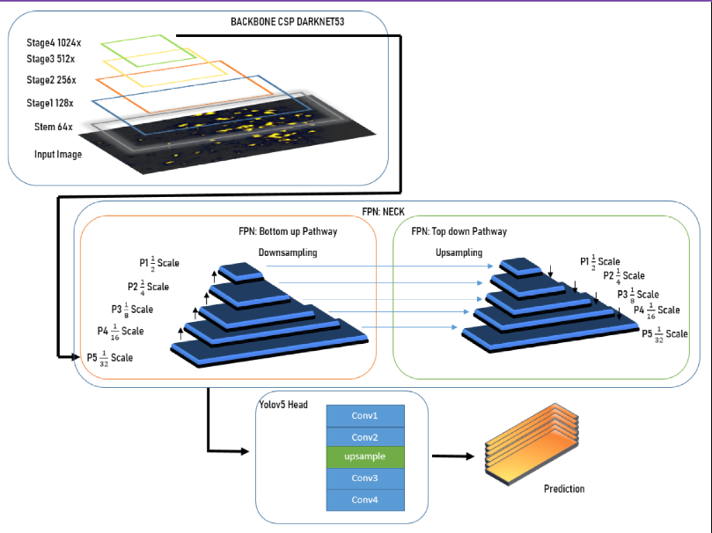

*5.12 Architecture of Feature Pyramid Network*

**5.4.6 Path Aggregation Network (PANet)**

PANet is present in the **neck**of the YOLOv5 model and it is mainly incorporated in the model to enhance the process of instance segmentation by preserving spatial information.

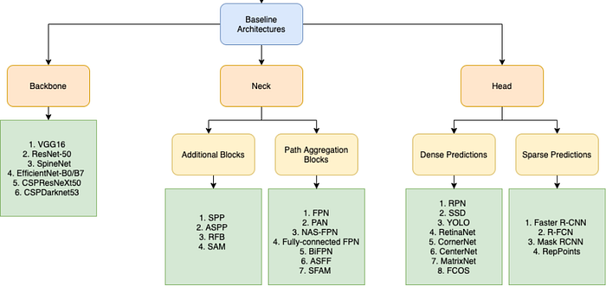

*5.13 Flowchart Path Aggregation Network*

Source: [YOLOv4 — Part 3: Bag of Specials | VisionWizard](https://medium.com/visionwizard/yolov4-version-2-bag-of-specials-fab1032b7fa0)

The reason why PANet is chosen for instance segmentation in YOLOv4 is because of its ability to preserve spatial information accurately which helps in proper localization of pixels for mask formation.

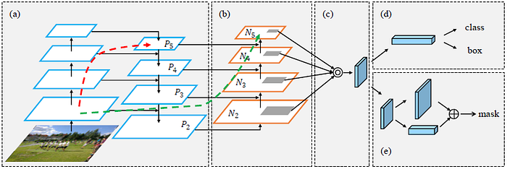

PANet Architecture [Source](http://openaccess.thecvf.com/content_cvpr_2018/papers/Liu_Path_Aggregation_Network_CVPR_2018_paper.pdf)

The properties which make PANet so accurate are:

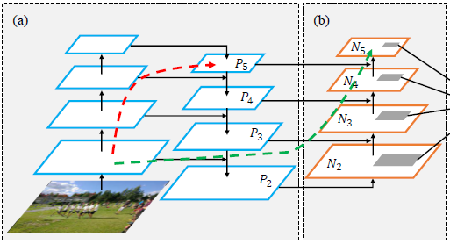

*5.14 Architecture of Path Aggregation Network*

Source:[Path Aggregation Network for Instance Segmentation](http://openaccess.thecvf.com/content_cvpr_2018/papers/Liu_Path_Aggregation_Network_CVPR_2018_paper.pdf)

As the image passes through the various layers of the neural network, the complexity of the features **increases** and the spatial resolution of the image **decreases** concurrently. Due to this, the pixel-level masks cannot be identified accurately by the high level features.

The FPN, which is used in YOLOv3, uses a top-down path to extract and combine **semantically rich features** with the precise localization information. But for producing masks for large objects, this technique can be excessively lengthy as the spatial information may need to be propagated to hundreds of layers.

PANet on the other hand, takes an additional bottom-up path to the top-down path taken by FPN. This helps in shortening that path by using clean lateral connections from the lower layers to the top ones. This is called the **“shortcut”** connection which is only about 10 layers.

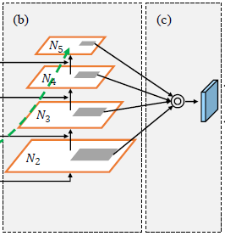

Source:[Path Aggregation Network for Instance Segmentation](http://openaccess.thecvf.com/content_cvpr_2018/papers/Liu_Path_Aggregation_Network_CVPR_2018_paper.pdf)

Previously used techniques like the Mask-RCNN used features from a single stage to make mask predictions. It used **ROI Align Pooling** to extract features from the higher levels if the region of interest was large. Although quite accurate, this could still lead to undesired results as sometimes two proposals with as minute as 10-pixel differences can be assigned to two different layers, whereas they are in fact quite similar proposals.

To avoid this, PANet uses features from all the layers, and lets the network decide which ones are useful. It performs ROI Align operation on each feature map to extract the features for the object. This is followed by an element-wise max fusion operation to enable the network to adapt new features.

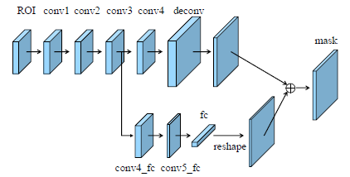

*5.15* [*Path Aggregation Network for Instance Segmentation*](http://openaccess.thecvf.com/content_cvpr_2018/papers/Liu_Path_Aggregation_Network_CVPR_2018_paper.pdf)

In Mask-RCNN, **Fully Convolutional Network (FCN)**is used instead of the fully-connected layers because it preserves the spatial information and reduces the number of parameters in the network. However, since the parameters are shared for all the spatial positions, the model doesn’t actually learn how to use pixel locations for making predictions; it will by default show sky in the top part of the image and roads in the bottom part.

Fully-connected layers, on the other hand, are **location sensitive** and can adapt to different spatial locations.

PANet uses information from both these layers to provide a more accurate mask prediction.

PANet conventionally adds the neighbouring layers together for doing mask predictions using the adaptive feature pooling. However, this approach is slightly twisted when PANet is employed in YOLOv5, such that instead of adding the neighbouring layers, a concatenation operation is applied on them which improves the accuracy of predictions.

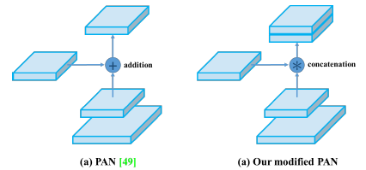

Source: [YOLOv4: Optimal Speed and Accuracy of Object Detection](https://scholar.google.com/scholar_url?url=https%3A%2F%2Farxiv.org%2Fabs%2F2004.10934&hl=en&sa=T&oi=gsb&ct=res&cd=0&d=4550423614333066109&ei=9NftXtGYC8GLywS73bvYCA&scisig=AAGBfm0sDu0prXuqXR0jKKFY2c5dTFV9mA)

Using a **ResNet-50**backbone, and training using multi-scaled images, PANet already outperforms Mask-RCNN and Champion of 2016, further it also won the 2017 COCO Instance Segmentation challenge and is ranked second in Object Detection task without large-batch training.

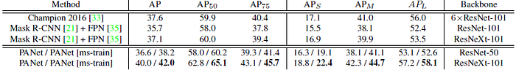

Source:[Path Aggregation Network for Instance Segmentation](http://openaccess.thecvf.com/content_cvpr_2018/papers/Liu_Path_Aggregation_Network_CVPR_2018_paper.pdf)

It also constantly outperforms Mask-RCNN on the Cityscapes dataset. And pre-trained on COCO, the model is able to outperform Mask-RCNN by 4.4 points.

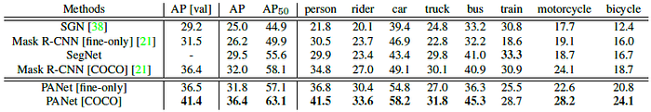

Source:[Path Aggregation Network for Instance Segmentation](http://openaccess.thecvf.com/content_cvpr_2018/papers/Liu_Path_Aggregation_Network_CVPR_2018_paper.pdf)

Due to its simple implementation and high performance, PANet was employed in YOLOv5, increasing the accuracy of prediction and making it twice as fast as the EfficientDet.

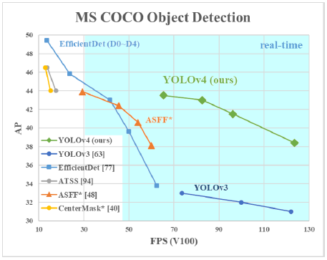

*5.16* [*YOLOv4: Optimal Speed and Accuracy of Object Detection*](https://scholar.google.com/scholar_url?url=https%3A%2F%2Farxiv.org%2Fabs%2F2004.10934&hl=en&sa=T&oi=gsb&ct=res&cd=0&d=4550423614333066109&ei=9NftXtGYC8GLywS73bvYCA&scisig=AAGBfm0sDu0prXuqXR0jKKFY2c5dTFV9mA)

In terms of APs, YOLOv5 achieved an AP value of 43.5% (65.7% on AP₅₀) on MS COCO dataset, and achieved a real time speed of ~65FPS on the Tesla V100, making it the fastest and the most accurate detectors of all time. The performance of YOLOv5 due to the inclusion of PANet instead of FPN used in YOLOv3 has been increased by a whopping 10–12% !!!

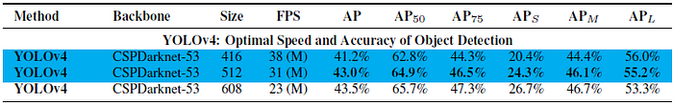

Source: [YOLOv4: Optimal Speed and Accuracy of Object Detection](https://scholar.google.com/scholar_url?url=https%3A%2F%2Farxiv.org%2Fabs%2F2004.10934&hl=en&sa=T&oi=gsb&ct=res&cd=0&d=4550423614333066109&ei=9NftXtGYC8GLywS73bvYCA&scisig=AAGBfm0sDu0prXuqXR0jKKFY2c5dTFV9mA)

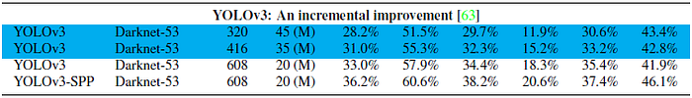

Source: [YOLOv5: Optimal Speed and Accuracy of Object Detection](https://scholar.google.com/scholar_url?url=https%3A%2F%2Farxiv.org%2Fabs%2F2004.10934&hl=en&sa=T&oi=gsb&ct=res&cd=0&d=4550423614333066109&ei=9NftXtGYC8GLywS73bvYCA&scisig=AAGBfm0sDu0prXuqXR0jKKFY2c5dTFV9mA)

PANet is fast, simple and very effective. It contains components that boost the information propagation through the pipelines. It pools features from all the levels and even shortens the distance between the lowermost and the top layers. And features are enriched for each level using augmented paths.

It has shown amazing results when tested in YOLOv5 and boosted its feature extraction process by a great amount, securing its position in the neck of the YOLOv5 model.

* 1. **Attention Mecahnism**

It is well known that attention plays an important role in human perception.One important property of a human visual system is that one does not attempt to process a whole scene at once. Instead, humans exploit a sequence of partial glimpses and selectively focus on salient parts in order to capture visual structure better .

Recently, there have been several attempts to incorporate attention processing to improve the performance of CNNs in large-scale classification tasks. Wang *et al*. propose *Residual Attention Network* which uses an encoder-decoder style attention module. By refining the feature maps, the network not only performs well but is also robust to noisy inputs. Instead of directly computing the 3D attention map, we decompose the process that learns channel attention and spatial attention separately. The separate attention generation process for 3D feature map has much less computational and parameter overhead, and therefore can be used as a plug-and-play module for pre-existing base CNN architectures.

More close to our work, Hu *etal* introduce a compact module to exploit the inter-channel relationship. In their *Squeeze-and-Excitation* module, they use global average-pooled features to compute channel-wise attention. However, we show that those are suboptimal features in order to infer fine channel attention, and we suggest to use max-pooled features as well. They also miss the spatial attention, which plays an important role in deciding ‘where’ to focus as shown in In our CBAM, we exploit both spatial and channel-wise attention based on an efficient architecture and empirically verify that exploiting both is superior to using only the channel-wise attention as . Moreover, we empirically show that our module is effective in detection tasks (MS-COCO and VOC). Especially, we achieve state-of-the-art performance just by placing our module on top of the existing one-shot detector in the VOC2007 test set.

Concurrently, *BAM* takes a similar approach, decomposing 3D attention map inference into channel and spatial. They place BAM module at every bottleneck of the network while we plug at every convolutional block.

The attention mechanism significantly enhances the performance of CNN-based deep learning models in classification tasks.Attention mechanism is a commonly used technique in deep learning to enhance the focus of neural networks on different parts of input data. It simulates the attention mechanism in the human visual system, allowing the network to selectively attend to information relevant to the current task. In traditional neural networks, every input is treated equally, and all features are simultaneously involved in computation. However, in certain tasks, only a small portion of the input may be crucial for the output. Attention mechanisms were introduced to address this issue. Attention mechanisms have achieved significant success in various deep learning tasks. For example, in image classification tasks, attention mechanisms can assist the network in automatically focusing on regions of an image that are relevant to the classification, thereby improving accuracy.

* + 1. **SE Module (Squeeze-and-Excitation)**

Proposed by Hu et al. (2017), the SE module enhances deep learning models by modeling correlations between different channels. - SE attention module learns to select useful characteristics while suppressing less reliable ones, improving feature recognition.

Components of SE module: Squeeze operation (Fsq), excitation operation (Fex), and fusion operation (Fscale). - SE Attention mechanism uses squeeze and excitation layers to determine the importance of information within an image, improving classification and detection accuracy.

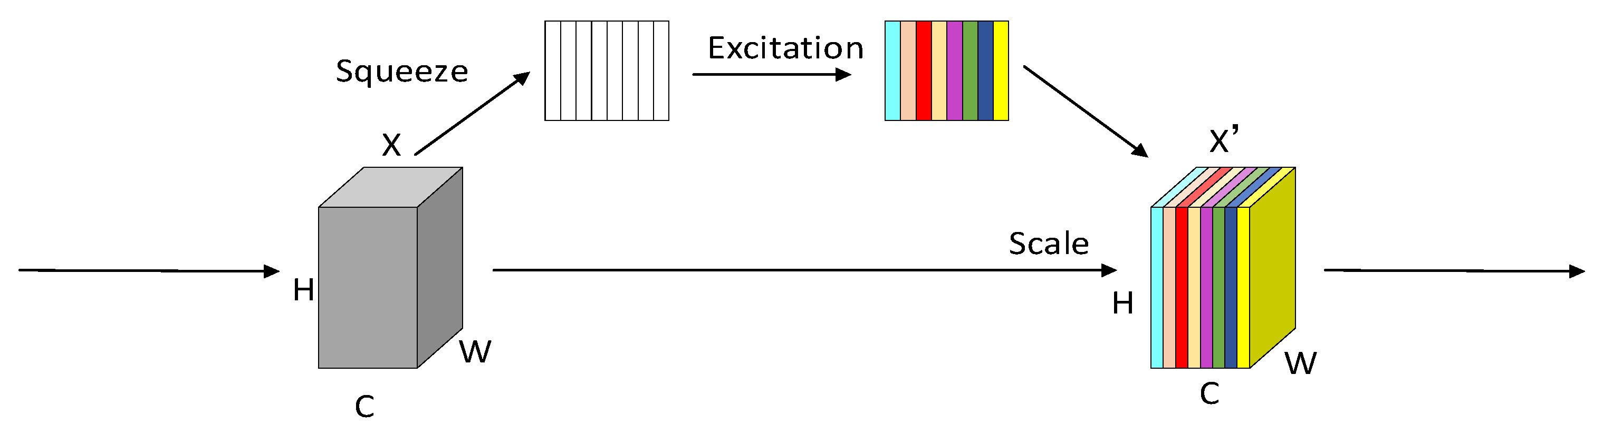

*5.17 SE Module (Squeeze-and-Excitation)*

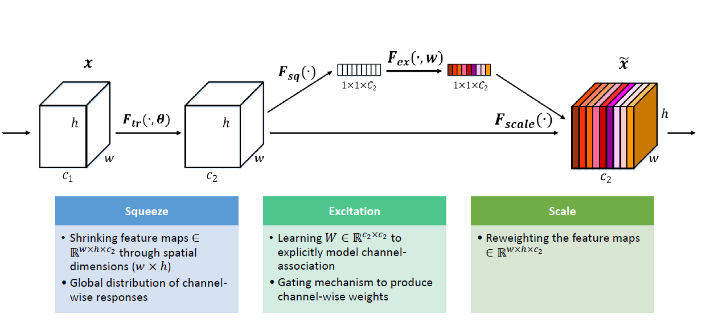

5.18 Architecture of *SE Module (Squeeze-and-Excitation)*

**5.5.2 CBAM (Convolutional Block Attention Module)**

CBAM module, proposed by Wang et al. (2021), combines spatial and channel attention to analyze inputs in three dimensions and identify important properties.

**Convolutional Block Attention Module (CBAM)** is an attention module for convolutional neural networks. Given an intermediate feature map, the module sequentially infers attention maps along two separate dimensions, channel and spatial, then the attention maps are multiplied to the input feature map for adaptive feature refinement.

- Channel attention module applies a filter to determine the relevance of each feature channel. - Spatial attention module calculates the significance of spatial features using convolutional layer operations. CBAM Attention mechanism focuses on important information within an image, increasing the accuracy of classification and detection.

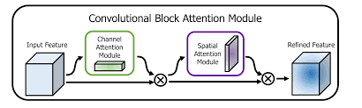

*5.19 CBAM (Convolutional Block Attention Module)*

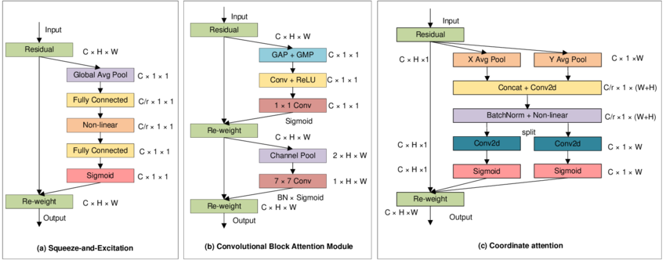

*5.20 Attention Mechanism*

CHAPTER-6

# IMPLEMENTATIONS

### Technology Description

### 

**Python**

Programming paradigms including functional, aspect-oriented, object-oriented, and structured programming are all supported by Python, a flexible language. Additionally, it offers extensions for other paradigms like design by contract and logic programming. Python supports dynamic name resolution and uses dynamic typing, reference counting, and garbage collection to manage memory. Python emphasizes code readability over slight performance gains, but when necessary, programmers can employ C extensions or just-in-time compilation to achieve quicker performance. With built-in capabilities like filter, map, and reduce functions, along with list comprehensions, dictionaries, sets, and generator expressions, Python's design also supports functional programming. The language has a helpful open-source community, as well as extensive support libraries and third-party modules.

#### Python's Advantages:

Third-Party Modules Availability Comprehensive Support Libraries Open Source and Community Development Learning Ease and Support Available User-Friendly Data Structures Productivity and Speed

### Techniques Used

**YOLO (YOU ONLY LOOK ONCE):** YOLO (You Only Look Once) is a renowned CNN-based object detection system celebrated for its rapid and accurate identification of objects within images. Developed by Ultralytics, YOLOv5 stands out as an evolution of this technique, trained on the extensive MS-COCO dataset comprising 80 object classes. Among its variants, YOLOv5s is preferred for its compact size and swift inference on real-time feeds, making it an apt choice for the current project. To further enhance YOLO's capabilities, a range of techniques such as batch normalization and optimized training strategies have been incorporated. The architecture of YOLOv5 encompasses an input phase for preprocessing and augmentation, a backbone network responsible for multi-scale feature extraction, and a neck network dedicated to integrating and enriching these features. Finally, the head output phase orchestrates the construction of bounding boxes, classification of objects, and prediction of outcomes, culminating in efficient and accurate object detection across diverse contexts.

The applications of YOLO (You Only Look Once) span various domains, showcasing its versatility and effectiveness in object detection tasks. In the realm of autonomous driving, YOLO plays a crucial role in detecting pedestrians, vehicles, and traffic signs, contributing to safer navigation and collision avoidance systems. In surveillance and security, YOLO enables real-time monitoring by detecting and tracking suspicious activities or intruders within video feeds, enhancing situational awareness and response capabilities. Moreover, YOLO finds utility in object tracking applications, enabling the continuous monitoring and analysis of moving objects in dynamic environments, essential for tasks like sports analytics and crowd management.

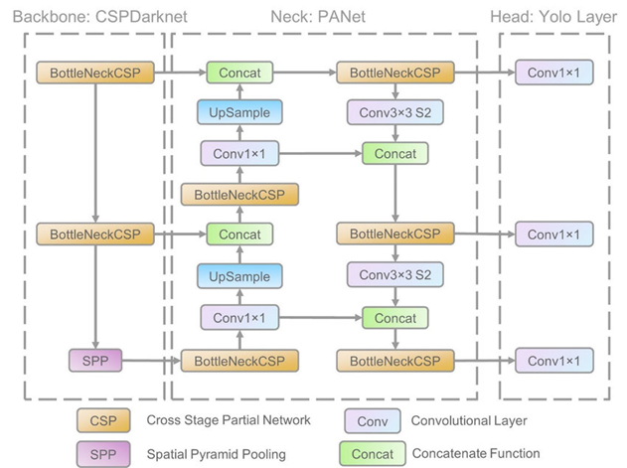

*6.1 Model of YOLO*

### Sample Code

**main.py**

#INDIAN SIGN LANGUAGE DETECTION USING YOLO-V5

#DATA COLLECTION

**Language Detection:https://universe.roboflow.com/yolov5-53hnk/isl-using-yolov5-0vwmd/dataset/7**

## importing required libraries

import os

import shutil

import random

#BUSINESS CASE: TO DETECT SIGN USING YOLOV5

!wget -O ISL_Yolov5.zip https://universe.roboflow.com/ds/2s5keI1SsW?key=qITr4FVBqf

!unzip ISL_Yolov5.zip -d ISL_Yolov5

#CLONING THE YOLO-V5 FILES FROM OFFICIAL REPOSITORY

!git clone https://github.com/ultralytics/yolov5.git

#CHANGING THE DIRECTORY

%cd yolov5/

#INSTALLING THE DEPENDENCIES

!pip install -r requirements.txt

#DOWNLOADING ALL PRE-TRAINED WEIGHTS

* yolov5l.pt: https://github.com/ultralytics/yolov5/releases/download/v6.0/yolov5l.pt

* yolov5m.pt: https://github.com/ultralytics/yolov5/releases/download/v6.0/yolov5m.pt

* yolov5s.pt: https://github.com/ultralytics/yolov5/releases/download/v6.0/yolov5s.pt

* for other models: https://github.com/ultralytics/yolov5/releases

!wget https://github.com/ultralytics/yolov5/releases/download/v6.0/yolov5s.pt

#STEPS BEFORE TRAINING CUSTOM DATASET:

Go to yolov5/data/

Open coco128.yaml

Edit the following inside it:

A. Training and Validation file path

B. Number of classes and Class names.

%cd /content/ISL_Yolov5

%cp -rf ./ /content/yolov5

%cd /content/yolov5

!python train.py --img 640 --batch 8 --epochs 50 --data /content/ISL_Yolov5/data.yaml  --weights  /content/yolov5/yolov5s.pt --nosave --cache

#VISUALIZING THE TRAINING METRICS

# Start tensorboard & Launch after you have started training

# logs save in the folder "runs"

%load_ext tensorboard

%tensorboard --logdir runs

from google.colab import drive

drive.mount('/content/drive')

!unzip '/content/drive/MyDrive/IS.zip' -d /content/

## inference or detection on new images

!python detect.py --source /content/magic/test/images --weights /content/yolov5/runs/train/exp/weights/last.pt --img 640 --save-txt --save-conf

# display result images

import glob

from IPython.display import Image, display

for imageName in glob.glob('/content/yolov5/runs/detect/exp2/*jpg'): #assuming JPG

    display(Image(filename=imageName))

    print("\n")

**Predict.py**

# YOLOv5 🚀 by Ultralytics, AGPL-3.0 license

"""

Run YOLOv5 classification inference on images, videos, directories, globs, YouTube, webcam, streams, etc.

Usage - sources:

    $ python classify/predict.py --weights yolov5s-cls.pt --source 0                               # webcam

                                                                   img.jpg                         # image

                                                                   vid.mp4                         # video

                                                                   screen                          # screenshot

                                                                   path/                           # directory

                                                                   list.txt                        # list of images

                                                                   list.streams                    # list of streams

                                                                   'path/*.jpg'                    # glob

                                                                   'https://youtu.be/LNwODJXcvt4'  # YouTube

                                                                   'rtsp://example.com/media.mp4'  # RTSP, RTMP, HTTP stream

Usage - formats:

    $ python classify/predict.py --weights yolov5s-cls.pt                 # PyTorch

                                           yolov5s-cls.torchscript        # TorchScript

                                           yolov5s-cls.onnx               # ONNX Runtime or OpenCV DNN with --dnn

                                           yolov5s-cls_openvino_model     # OpenVINO

                                           yolov5s-cls.engine             # TensorRT

                                           yolov5s-cls.mlmodel            # CoreML (macOS-only)

                                           yolov5s-cls_saved_model        # TensorFlow SavedModel

                                           yolov5s-cls.pb                 # TensorFlow GraphDef

                                           yolov5s-cls.tflite             # TensorFlow Lite

                                           yolov5s-cls_edgetpu.tflite     # TensorFlow Edge TPU

                                           yolov5s-cls_paddle_model       # PaddlePaddle

"""

import argparse

import os

import platform

import sys

from pathlib import Path

import torch

import torch.nn.functional as F

FILE = Path(__file__).resolve()

ROOT = FILE.parents[1]  # YOLOv5 root directory

if str(ROOT) not in sys.path:

    sys.path.append(str(ROOT))  # add ROOT to PATH

ROOT = Path(os.path.relpath(ROOT, Path.cwd()))  # relative

from ultralytics.utils.plotting import Annotator

from models.common import DetectMultiBackend

from utils.augmentations import classify_transforms

from utils.dataloaders import IMG_FORMATS, VID_FORMATS, LoadImages, LoadScreenshots, LoadStreams

from utils.general import (

    LOGGER,

    Profile,

    check_file,

    check_img_size,

    check_imshow,

    check_requirements,

    colorstr,

    cv2,

    increment_path,

    print_args,

    strip_optimizer,

)

from utils.torch_utils import select_device, smart_inference_mode

@smart_inference_mode()

def run(

    weights=ROOT / "yolov5s-cls.pt",  # model.pt path(s)

    source=ROOT / "data/images",  # file/dir/URL/glob/screen/0(webcam)

    data=ROOT / "data/coco128.yaml",  # dataset.yaml path

    imgsz=(224, 224),  # inference size (height, width)

    device="",  # cuda device, i.e. 0 or 0,1,2,3 or cpu

    view_img=False,  # show results

    save_txt=False,  # save results to *.txt

    nosave=False,  # do not save images/videos

    augment=False,  # augmented inference

    visualize=False,  # visualize features

    update=False,  # update all models

    project=ROOT / "runs/predict-cls",  # save results to project/name

    name="exp",  # save results to project/name

    exist_ok=False,  # existing project/name ok, do not increment

    half=False,  # use FP16 half-precision inference

    dnn=False,  # use OpenCV DNN for ONNX inference

    vid_stride=1,  # video frame-rate stride

):

    source = str(source)

    save_img = not nosave and not source.endswith(".txt")  # save inference images

    is_file = Path(source).suffix[1:] in (IMG_FORMATS + VID_FORMATS)

    is_url = source.lower().startswith(("rtsp://", "rtmp://", "http://", "https://"))

    webcam = source.isnumeric() or source.endswith(".streams") or (is_url and not is_file)

    screenshot = source.lower().startswith("screen")

    if is_url and is_file:

        source = check_file(source)  # download

    # Directories

    save_dir = increment_path(Path(project) / name, exist_ok=exist_ok)  # increment run

    (save_dir / "labels" if save_txt else save_dir).mkdir(parents=True, exist_ok=True)  # make dir

    # Load model

    device = select_device(device)

    model = DetectMultiBackend(weights, device=device, dnn=dnn, data=data, fp16=half)

    stride, names, pt = model.stride, model.names, model.pt

    imgsz = check_img_size(imgsz, s=stride)  # check image size

    # Dataloader

    bs = 1  # batch_size

    if webcam:

        view_img = check_imshow(warn=True)

        dataset = LoadStreams(source, img_size=imgsz, transforms=classify_transforms(imgsz[0]), vid_stride=vid_stride)

        bs = len(dataset)

    elif screenshot:

        dataset = LoadScreenshots(source, img_size=imgsz, stride=stride, auto=pt)

    else:

        dataset = LoadImages(source, img_size=imgsz, transforms=classify_transforms(imgsz[0]), vid_stride=vid_stride)

    vid_path, vid_writer = [None] * bs, [None] * bs

    # Run inference

    model.warmup(imgsz=(1 if pt else bs, 3, *imgsz))  # warmup

    seen, windows, dt = 0, [], (Profile(device=device), Profile(device=device), Profile(device=device))

    for path, im, im0s, vid_cap, s in dataset:

        with dt[0]:

            im = torch.Tensor(im).to(model.device)

            im = im.half() if model.fp16 else im.float()  # uint8 to fp16/32

            if len(im.shape) == 3:

                im = im[None]  # expand for batch dim

        # Inference

        with dt[1]:

            results = model(im)

        # Post-process

        with dt[2]:

            pred = F.softmax(results, dim=1)  # probabilities

        # Process predictions

        for i, prob in enumerate(pred):  # per image

            seen += 1

            if webcam:  # batch_size >= 1

                p, im0, frame = path[i], im0s[i].copy(), dataset.count

                s += f"{i}: "

            else:

                p, im0, frame = path, im0s.copy(), getattr(dataset, "frame", 0)

            p = Path(p)  # to Path

            save_path = str(save_dir / p.name)  # im.jpg

            txt_path = str(save_dir / "labels" / p.stem) + ("" if dataset.mode == "image" else f"_{frame}")  # im.txt

            s += "%gx%g " % im.shape[2:]  # print string

            annotator = Annotator(im0, example=str(names), pil=True)

            # Print results

            top5i = prob.argsort(0, descending=True)[:5].tolist()  # top 5 indices

            s += f"{', '.join(f'{names[j]} {prob[j]:.2f}' for j in top5i)}, "

            # Write results

            text = "\n".join(f"{prob[j]:.2f} {names[j]}" for j in top5i)

            if save_img or view_img:  # Add bbox to image

                annotator.text([32, 32], text, txt_color=(255, 255, 255))

            if save_txt:  # Write to file

                with open(f"{txt_path}.txt", "a") as f:

                    f.write(text + "\n")

            # Stream results

            im0 = annotator.result()

            if view_img:

                if platform.system() == "Linux" and p not in windows:

                    windows.append(p)

                    cv2.namedWindow(str(p), cv2.WINDOW_NORMAL | cv2.WINDOW_KEEPRATIO)  # allow window resize (Linux)

                    cv2.resizeWindow(str(p), im0.shape[1], im0.shape[0])

                cv2.imshow(str(p), im0)

                cv2.waitKey(1)  # 1 millisecond

            # Save results (image with detections)

            if save_img:

                if dataset.mode == "image":

                    cv2.imwrite(save_path, im0)

                else:  # 'video' or 'stream'

                    if vid_path[i] != save_path:  # new video

                        vid_path[i] = save_path

                        if isinstance(vid_writer[i], cv2.VideoWriter):

                            vid_writer[i].release()  # release previous video writer

                        if vid_cap:  # video

                            fps = vid_cap.get(cv2.CAP_PROP_FPS)

                            w = int(vid_cap.get(cv2.CAP_PROP_FRAME_WIDTH))

                            h = int(vid_cap.get(cv2.CAP_PROP_FRAME_HEIGHT))

                        else:  # stream

                            fps, w, h = 30, im0.shape[1], im0.shape[0]

                        save_path = str(Path(save_path).with_suffix(".mp4"))  # force *.mp4 suffix on results videos

                        vid_writer[i] = cv2.VideoWriter(save_path, cv2.VideoWriter_fourcc(*"mp4v"), fps, (w, h))

                    vid_writer[i].write(im0)

        # Print time (inference-only)

        LOGGER.info(f"{s}{dt[1].dt * 1E3:.1f}ms")

    # Print results

    t = tuple(x.t / seen * 1e3 for x in dt)  # speeds per image

    LOGGER.info(f"Speed: %.1fms pre-process, %.1fms inference, %.1fms NMS per image at shape {(1, 3, *imgsz)}" % t)

    if save_txt or save_img:

        s = f"\n{len(list(save_dir.glob('labels/*.txt')))} labels saved to {save_dir / 'labels'}" if save_txt else ""

        LOGGER.info(f"Results saved to {colorstr('bold', save_dir)}{s}")

    if update:

        strip_optimizer(weights[0])  # update model (to fix SourceChangeWarning)

def parse_opt():

    """Parses command line arguments for YOLOv5 inference settings including model, source, device, and image size."""

    parser = argparse.ArgumentParser()

    parser.add_argument("--weights", nargs="+", type=str, default=ROOT / "yolov5s-cls.pt", help="model path(s)")

    parser.add_argument("--source", type=str, default=ROOT / "data/images", help="file/dir/URL/glob/screen/0(webcam)")

    parser.add_argument("--data", type=str, default=ROOT / "data/coco128.yaml", help="(optional) dataset.yaml path")

    parser.add_argument("--imgsz", "--img", "--img-size", nargs="+", type=int, default=[224], help="inference size h,w")

    parser.add_argument("--device", default="", help="cuda device, i.e. 0 or 0,1,2,3 or cpu")

    parser.add_argument("--view-img", action="store_true", help="show results")

    parser.add_argument("--save-txt", action="store_true", help="save results to *.txt")

    parser.add_argument("--nosave", action="store_true", help="do not save images/videos")

    parser.add_argument("--augment", action="store_true", help="augmented inference")

    parser.add_argument("--visualize", action="store_true", help="visualize features")

    parser.add_argument("--update", action="store_true", help="update all models")

    parser.add_argument("--project", default=ROOT / "runs/predict-cls", help="save results to project/name")

    parser.add_argument("--name", default="exp", help="save results to project/name")

    parser.add_argument("--exist-ok", action="store_true", help="existing project/name ok, do not increment")

    parser.add_argument("--half", action="store_true", help="use FP16 half-precision inference")

    parser.add_argument("--dnn", action="store_true", help="use OpenCV DNN for ONNX inference")

    parser.add_argument("--vid-stride", type=int, default=1, help="video frame-rate stride")

    opt = parser.parse_args()

    opt.imgsz *= 2 if len(opt.imgsz) == 1 else 1  # expand

    print_args(vars(opt))

    return opt

def main(opt):

    """Executes YOLOv5 model inference with options for ONNX DNN and video frame-rate stride adjustments."""

    check_requirements(ROOT / "requirements.txt", exclude=("tensorboard", "thop"))

    run(**vars(opt))

if __name__ == "__main__":

    opt = parse_opt()

    main(opt)

**Detect.py**

# YOLOv5 🚀 by Ultralytics, AGPL-3.0 license

"""

Run YOLOv5 detection inference on images, videos, directories, globs, YouTube, webcam, streams, etc.

Usage - sources:

    $ python detect.py --weights yolov5s.pt --source 0                               # webcam

                                                     img.jpg                         # image

                                                     vid.mp4                         # video

                                                     screen                          # screenshot

                                                     path/                           # directory

                                                     list.txt                        # list of images

                                                     list.streams                    # list of streams

                                                     'path/*.jpg'                    # glob

                                                     'https://youtu.be/LNwODJXcvt4'  # YouTube

                                                     'rtsp://example.com/media.mp4'  # RTSP, RTMP, HTTP stream

Usage - formats:

    $ python detect.py --weights yolov5s.pt                 # PyTorch

                                 yolov5s.torchscript        # TorchScript

                                 yolov5s.onnx               # ONNX Runtime or OpenCV DNN with --dnn

                                 yolov5s_openvino_model     # OpenVINO

                                 yolov5s.engine             # TensorRT

                                 yolov5s.mlmodel            # CoreML (macOS-only)

                                 yolov5s_saved_model        # TensorFlow SavedModel

                                 yolov5s.pb                 # TensorFlow GraphDef

                                 yolov5s.tflite             # TensorFlow Lite

                                 yolov5s_edgetpu.tflite     # TensorFlow Edge TPU

                                 yolov5s_paddle_model       # PaddlePaddle

"""

import argparse

import csv

import os

import platform

import sys

from pathlib import Path

import torch

FILE = Path(__file__).resolve()

ROOT = FILE.parents[0]  # YOLOv5 root directory

if str(ROOT) not in sys.path:

    sys.path.append(str(ROOT))  # add ROOT to PATH

ROOT = Path(os.path.relpath(ROOT, Path.cwd()))  # relative

from ultralytics.utils.plotting import Annotator, colors, save_one_box

from models.common import DetectMultiBackend

from utils.dataloaders import IMG_FORMATS, VID_FORMATS, LoadImages, LoadScreenshots, LoadStreams

from utils.general import (

    LOGGER,

    Profile,

    check_file,

    check_img_size,

    check_imshow,

    check_requirements,

    colorstr,

    cv2,

    increment_path,

    non_max_suppression,

    print_args,

    scale_boxes,

    strip_optimizer,

    xyxy2xywh,

)

from utils.torch_utils import select_device, smart_inference_mode

@smart_inference_mode()

def run(

    weights=ROOT / "yolov5s.pt",  # model path or triton URL

    source=ROOT / "data/images",  # file/dir/URL/glob/screen/0(webcam)

    data=ROOT / "data/coco128.yaml",  # dataset.yaml path

    imgsz=(640, 640),  # inference size (height, width)

    conf_thres=0.25,  # confidence threshold

    iou_thres=0.45,  # NMS IOU threshold

    max_det=1000,  # maximum detections per image

    device="",  # cuda device, i.e. 0 or 0,1,2,3 or cpu

    view_img=False,  # show results

    save_txt=False,  # save results to *.txt

    save_csv=False,  # save results in CSV format

    save_conf=False,  # save confidences in --save-txt labels

    save_crop=False,  # save cropped prediction boxes

    nosave=False,  # do not save images/videos

    classes=None,  # filter by class: --class 0, or --class 0 2 3

    agnostic_nms=False,  # class-agnostic NMS

    augment=False,  # augmented inference

    visualize=False,  # visualize features

    update=False,  # update all models

    project=ROOT / "runs/detect",  # save results to project/name

    name="exp",  # save results to project/name

    exist_ok=False,  # existing project/name ok, do not increment

    line_thickness=3,  # bounding box thickness (pixels)

    hide_labels=False,  # hide labels

    hide_conf=False,  # hide confidences

    half=False,  # use FP16 half-precision inference

    dnn=False,  # use OpenCV DNN for ONNX inference

    vid_stride=1,  # video frame-rate stride

):

    source = str(source)

    save_img = not nosave and not source.endswith(".txt")  # save inference images

    is_file = Path(source).suffix[1:] in (IMG_FORMATS + VID_FORMATS)

    is_url = source.lower().startswith(("rtsp://", "rtmp://", "http://", "https://"))

    webcam = source.isnumeric() or source.endswith(".streams") or (is_url and not is_file)

    screenshot = source.lower().startswith("screen")

    if is_url and is_file:

        source = check_file(source)  # download

    # Directories

    save_dir = increment_path(Path(project) / name, exist_ok=exist_ok)  # increment run

    (save_dir / "labels" if save_txt else save_dir).mkdir(parents=True, exist_ok=True)  # make dir

    # Load model

    device = select_device(device)

    model = DetectMultiBackend(weights, device=device, dnn=dnn, data=data, fp16=half)

    stride, names, pt = model.stride, model.names, model.pt

    imgsz = check_img_size(imgsz, s=stride)  # check image size

    # Dataloader

    bs = 1  # batch_size

    if webcam:

        view_img = check_imshow(warn=True)

        dataset = LoadStreams(source, img_size=imgsz, stride=stride, auto=pt, vid_stride=vid_stride)

        bs = len(dataset)

    elif screenshot:

        dataset = LoadScreenshots(source, img_size=imgsz, stride=stride, auto=pt)

    else:

        dataset = LoadImages(source, img_size=imgsz, stride=stride, auto=pt, vid_stride=vid_stride)

    vid_path, vid_writer = [None] * bs, [None] * bs

    # Run inference

    model.warmup(imgsz=(1 if pt or model.triton else bs, 3, *imgsz))  # warmup

    seen, windows, dt = 0, [], (Profile(device=device), Profile(device=device), Profile(device=device))

    for path, im, im0s, vid_cap, s in dataset:

        with dt[0]:

            im = torch.from_numpy(im).to(model.device)

            im = im.half() if model.fp16 else im.float()  # uint8 to fp16/32

            im /= 255  # 0 - 255 to 0.0 - 1.0

            if len(im.shape) == 3:

                im = im[None]  # expand for batch dim

            if model.xml and im.shape[0] > 1:

                ims = torch.chunk(im, im.shape[0], 0)

        # Inference

        with dt[1]:

            visualize = increment_path(save_dir / Path(path).stem, mkdir=True) if visualize else False

            if model.xml and im.shape[0] > 1:

                pred = None

                for image in ims:

                    if pred is None:

                        pred = model(image, augment=augment, visualize=visualize).unsqueeze(0)

                    else:

                        pred = torch.cat((pred, model(image, augment=augment, visualize=visualize).unsqueeze(0)), dim=0)

                pred = [pred, None]

            else:

                pred = model(im, augment=augment, visualize=visualize)

        # NMS

        with dt[2]:

            pred = non_max_suppression(pred, conf_thres, iou_thres, classes, agnostic_nms, max_det=max_det)

        # Second-stage classifier (optional)

        # pred = utils.general.apply_classifier(pred, classifier_model, im, im0s)

        # Define the path for the CSV file

        csv_path = save_dir / "predictions.csv"

        # Create or append to the CSV file

        def write_to_csv(image_name, prediction, confidence):

            """Writes prediction data for an image to a CSV file, appending if the file exists."""

            data = {"Image Name": image_name, "Prediction": prediction, "Confidence": confidence}

            with open(csv_path, mode="a", newline="") as f:

                writer = csv.DictWriter(f, fieldnames=data.keys())

                if not csv_path.is_file():

                    writer.writeheader()

                writer.writerow(data)

        # Process predictions

        for i, det in enumerate(pred):  # per image

            seen += 1

            if webcam:  # batch_size >= 1

                p, im0, frame = path[i], im0s[i].copy(), dataset.count

                s += f"{i}: "

            else:

                p, im0, frame = path, im0s.copy(), getattr(dataset, "frame", 0)

            p = Path(p)  # to Path

            save_path = str(save_dir / p.name)  # im.jpg

            txt_path = str(save_dir / "labels" / p.stem) + ("" if dataset.mode == "image" else f"_{frame}")  # im.txt

            s += "%gx%g " % im.shape[2:]  # print string

            gn = torch.tensor(im0.shape)[[1, 0, 1, 0]]  # normalization gain whwh

            imc = im0.copy() if save_crop else im0  # for save_crop

            annotator = Annotator(im0, line_width=line_thickness, example=str(names))

            if len(det):

                # Rescale boxes from img_size to im0 size

                det[:, :4] = scale_boxes(im.shape[2:], det[:, :4], im0.shape).round()

                # Print results

                for c in det[:, 5].unique():

                    n = (det[:, 5] == c).sum()  # detections per class

                    s += f"{n} {names[int(c)]}{'s' * (n > 1)}, "  # add to string

                # Write results

                for *xyxy, conf, cls in reversed(det):

                    c = int(cls)  # integer class

                    label = names[c] if hide_conf else f"{names[c]}"

                    confidence = float(conf)

                    confidence_str = f"{confidence:.2f}"

                    if save_csv:

                        write_to_csv(p.name, label, confidence_str)

                    if save_txt:  # Write to file

                        xywh = (xyxy2xywh(torch.tensor(xyxy).view(1, 4)) / gn).view(-1).tolist()  # normalized xywh

                        line = (cls, *xywh, conf) if save_conf else (cls, *xywh)  # label format

                        with open(f"{txt_path}.txt", "a") as f:

                            f.write(("%g " * len(line)).rstrip() % line + "\n")

                    if save_img or save_crop or view_img:  # Add bbox to image

                        c = int(cls)  # integer class

                        label = None if hide_labels else (names[c] if hide_conf else f"{names[c]} {conf:.2f}")

                        annotator.box_label(xyxy, label, color=colors(c, True))

                    if save_crop:

                        save_one_box(xyxy, imc, file=save_dir / "crops" / names[c] / f"{p.stem}.jpg", BGR=True)

            # Stream results

            im0 = annotator.result()

            if view_img:

                if platform.system() == "Linux" and p not in windows:

                    windows.append(p)

                    cv2.namedWindow(str(p), cv2.WINDOW_NORMAL | cv2.WINDOW_KEEPRATIO)  # allow window resize (Linux)

                    cv2.resizeWindow(str(p), im0.shape[1], im0.shape[0])

                cv2.imshow(str(p), im0)

                cv2.waitKey(1)  # 1 millisecond

            # Save results (image with detections)

            if save_img:

                if dataset.mode == "image":

                    cv2.imwrite(save_path, im0)

                else:  # 'video' or 'stream'

                    if vid_path[i] != save_path:  # new video

                        vid_path[i] = save_path

                        if isinstance(vid_writer[i], cv2.VideoWriter):

                            vid_writer[i].release()  # release previous video writer

                        if vid_cap:  # video

                            fps = vid_cap.get(cv2.CAP_PROP_FPS)

                            w = int(vid_cap.get(cv2.CAP_PROP_FRAME_WIDTH))

                            h = int(vid_cap.get(cv2.CAP_PROP_FRAME_HEIGHT))

                        else:  # stream

                            fps, w, h = 30, im0.shape[1], im0.shape[0]

                        save_path = str(Path(save_path).with_suffix(".mp4"))  # force *.mp4 suffix on results videos

                        vid_writer[i] = cv2.VideoWriter(save_path, cv2.VideoWriter_fourcc(*"mp4v"), fps, (w, h))

                    vid_writer[i].write(im0)

        # Print time (inference-only)

        LOGGER.info(f"{s}{'' if len(det) else '(no detections), '}{dt[1].dt * 1E3:.1f}ms")

    # Print results

    t = tuple(x.t / seen * 1e3 for x in dt)  # speeds per image

    LOGGER.info(f"Speed: %.1fms pre-process, %.1fms inference, %.1fms NMS per image at shape {(1, 3, *imgsz)}" % t)

    if save_txt or save_img:

        s = f"\n{len(list(save_dir.glob('labels/*.txt')))} labels saved to {save_dir / 'labels'}" if save_txt else ""

        LOGGER.info(f"Results saved to {colorstr('bold', save_dir)}{s}")

    if update:

        strip_optimizer(weights[0])  # update model (to fix SourceChangeWarning)

def parse_opt():

    """Parses command-line arguments for YOLOv5 detection, setting inference options and model configurations."""

    parser = argparse.ArgumentParser()

    parser.add_argument("--weights", nargs="+", type=str, default=ROOT / "yolov5s.pt", help="model path or triton URL")

    parser.add_argument("--source", type=str, default=ROOT / "data/images", help="file/dir/URL/glob/screen/0(webcam)")

    parser.add_argument("--data", type=str, default=ROOT / "data/coco128.yaml", help="(optional) dataset.yaml path")

    parser.add_argument("--imgsz", "--img", "--img-size", nargs="+", type=int, default=[640], help="inference size h,w")

    parser.add_argument("--conf-thres", type=float, default=0.25, help="confidence threshold")

    parser.add_argument("--iou-thres", type=float, default=0.45, help="NMS IoU threshold")

    parser.add_argument("--max-det", type=int, default=1000, help="maximum detections per image")

    parser.add_argument("--device", default="", help="cuda device, i.e. 0 or 0,1,2,3 or cpu")

    parser.add_argument("--view-img", action="store_true", help="show results")

    parser.add_argument("--save-txt", action="store_true", help="save results to *.txt")

    parser.add_argument("--save-csv", action="store_true", help="save results in CSV format")

    parser.add_argument("--save-conf", action="store_true", help="save confidences in --save-txt labels")

    parser.add_argument("--save-crop", action="store_true", help="save cropped prediction boxes")

    parser.add_argument("--nosave", action="store_true", help="do not save images/videos")

    parser.add_argument("--classes", nargs="+", type=int, help="filter by class: --classes 0, or --classes 0 2 3")

    parser.add_argument("--agnostic-nms", action="store_true", help="class-agnostic NMS")

    parser.add_argument("--augment", action="store_true", help="augmented inference")

    parser.add_argument("--visualize", action="store_true", help="visualize features")

    parser.add_argument("--update", action="store_true", help="update all models")

    parser.add_argument("--project", default=ROOT / "runs/detect", help="save results to project/name")

    parser.add_argument("--name", default="exp", help="save results to project/name")

    parser.add_argument("--exist-ok", action="store_true", help="existing project/name ok, do not increment")

    parser.add_argument("--line-thickness", default=3, type=int, help="bounding box thickness (pixels)")

    parser.add_argument("--hide-labels", default=False, action="store_true", help="hide labels")

    parser.add_argument("--hide-conf", default=False, action="store_true", help="hide confidences")

    parser.add_argument("--half", action="store_true", help="use FP16 half-precision inference")

    parser.add_argument("--dnn", action="store_true", help="use OpenCV DNN for ONNX inference")

    parser.add_argument("--vid-stride", type=int, default=1, help="video frame-rate stride")

    opt = parser.parse_args()

    opt.imgsz *= 2 if len(opt.imgsz) == 1 else 1  # expand

    print_args(vars(opt))

    return opt

def main(opt):

    """Executes YOLOv5 model inference with given options, checking requirements before running the model."""

    check_requirements(ROOT / "requirements.txt", exclude=("tensorboard", "thop"))

    run(**vars(opt))

if __name__ == "__main__":

    opt = parse_opt()

    main(opt)

CHAPTER-7

# OUTPUT SCREENSHOTS

### 7 Output Screenshots

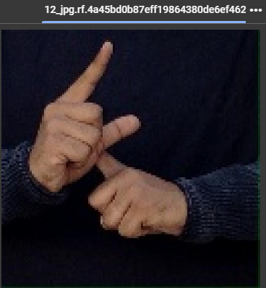 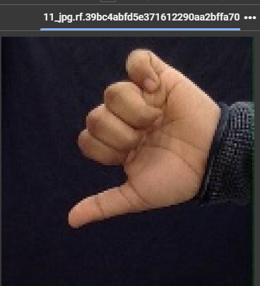

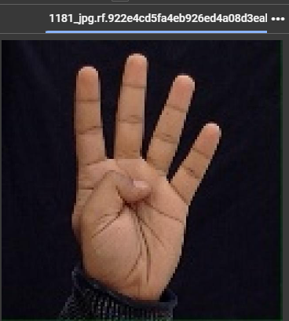 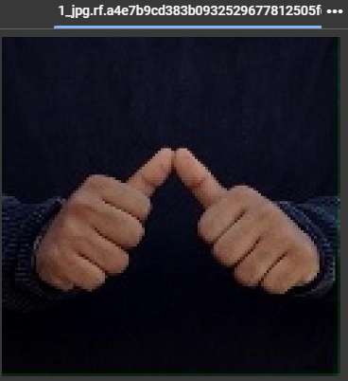

*7.1 Undetected Images*

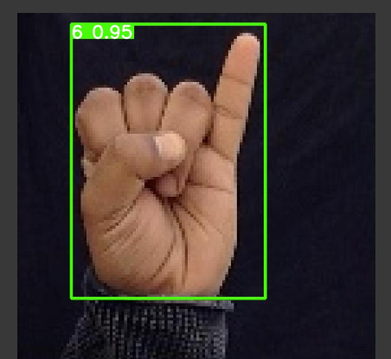 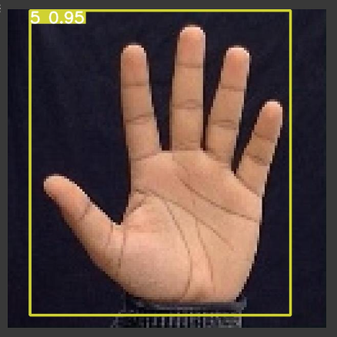

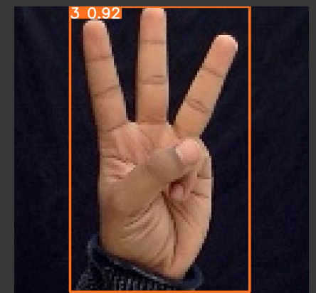 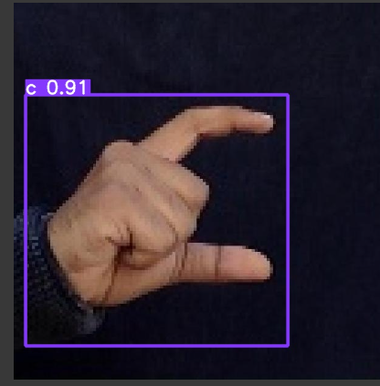

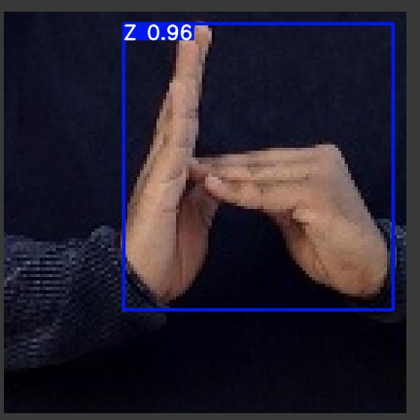

7.2 Detected Images

CHAPTER-8

# TESTING

**8 Visualizing the training metrics**

Precision, recall, F1 score, mAP (mean Average Precision), and other evaluation metrics play crucial roles in assessing the performance of machine learning models, particularly in tasks like object detection, classification, and segmentation.

**1. Precision:** Precision measures the accuracy of positive predictions made by the model. It calculates the ratio of true positive predictions to the total number of positive predictions (true positives + false positives). Precision indicates how many of the predicted positive instances are actually relevant. A high precision score indicates that the model has a low false positive rate, meaning it rarely misclassifies negative instances as positive.

**2. Recall:** Recall (also known as sensitivity or true positive rate) measures the ability of the model to correctly identify positive instances. It calculates the ratio of true positive predictions to the total number of actual positive instances (true positives + false negatives). Recall indicates the completeness of the model's predictions, showing how many of the actual positive instances were correctly identified. A high recall score indicates that the model captures a large proportion of positive instances, minimizing false negatives.

**3.F1 Score:** The F1 score is the harmonic mean of precision and recall. It provides a balanced measure of a model's performance by considering both precision and recall. The F1 score reaches its best value at 1 (perfect precision and recall) and worst at 0. It is a useful metric when there is an imbalance between the number of positive and negative instances in the dataset. The F1 score penalizes models that have imbalanced precision and recall values.

**4. mAP (mean Average Precision):** mAP is a popular metric for evaluating object detection models. It measures the average precision across all classes in the dataset. For each class, precision and recall values are calculated at different confidence thresholds, and then the average precision is computed by taking the area under the precision-recall curve. Finally, the mAP is calculated as the mean of the average precision values for all classes. A higher mAP indicates better performance in object detection tasks.

Evaluation metrics like precision, recall, F1 score, and mAP provide quantitative measures of a model's performance, helping in the following ways during testing:

- **Performance Comparison:** These metrics enable comparisons between different models or variations of the same model to determine which one performs better on the given task.

**- Model Selection:** Evaluation metrics help in selecting the most suitable model for deployment based on its performance on validation or test data.

- **Identification of Weaknesses:** By analyzing precision, recall, and F1 score, one can identify the strengths and weaknesses of the model, such as its tendency to produce false positives or false negatives.

**- Threshold Optimization:** Precision-recall curves and F1 score can aid in optimizing decision thresholds to achieve desired trade-offs between precision and recall based on specific application requirements.

**- Generalization Assessment:** These metrics assess how well the model generalizes to unseen data and its ability to perform reliably in real-world scenarios beyond the training dataset.

Overall, precision, recall, F1 score, and mAP are essential tools for evaluating model performance and guiding improvements during testing phase of machine learning model development.

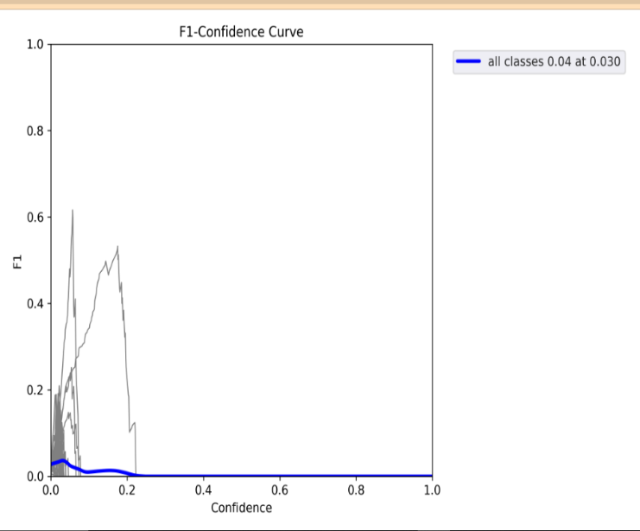 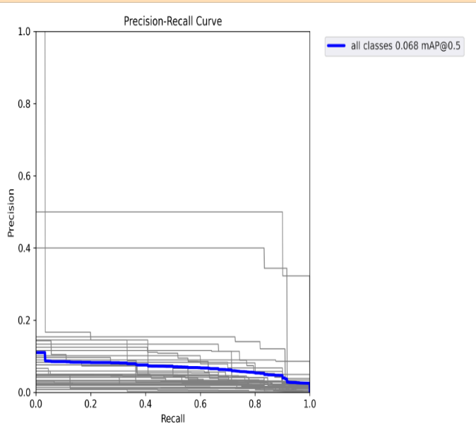

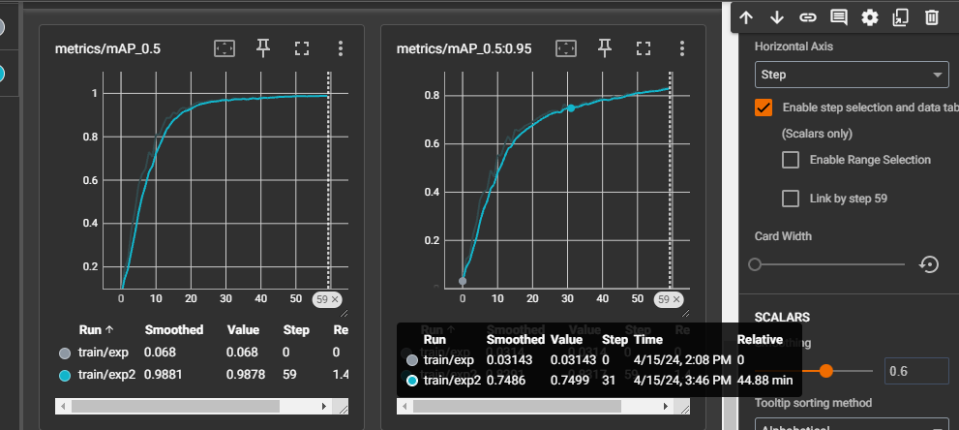

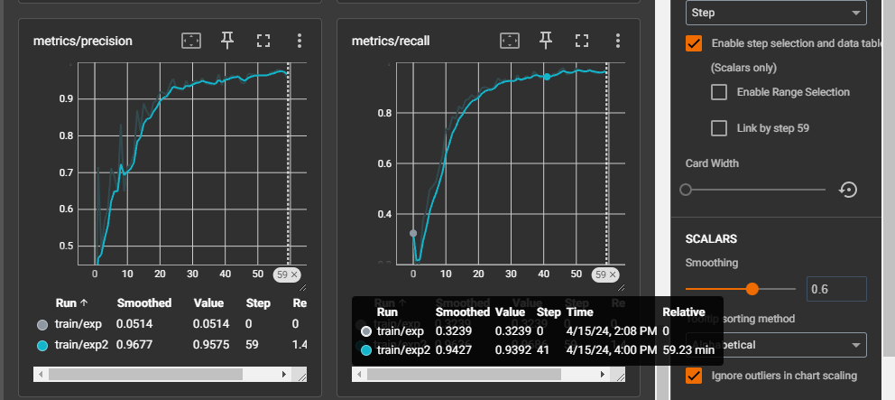 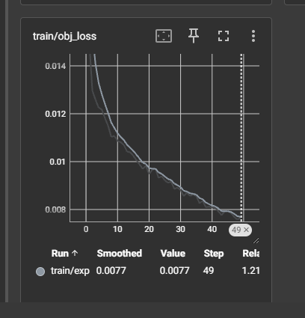

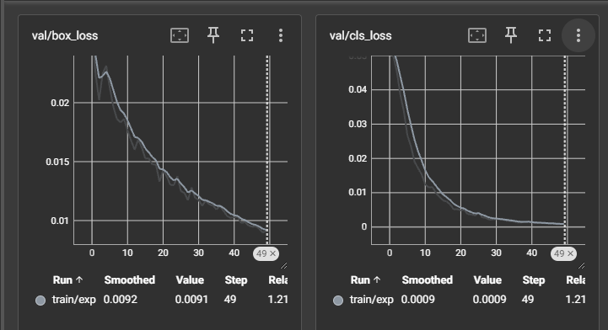

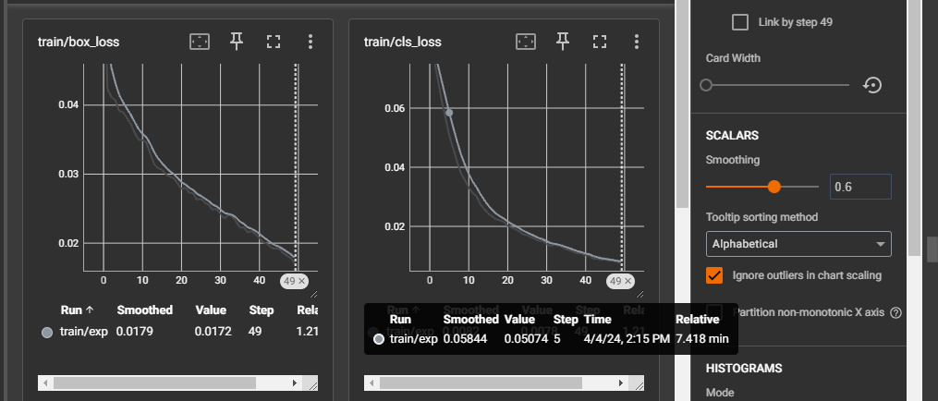

*8.1 Evaluation Metrics*

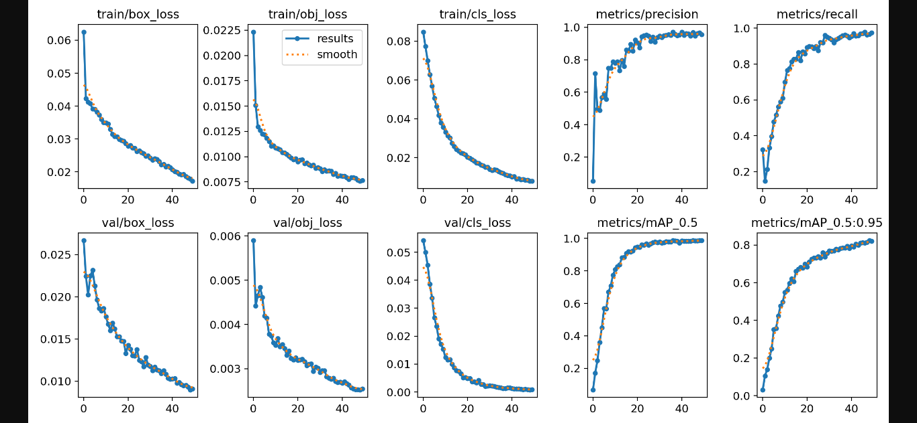

*8.2 Graphs of Evaluation Metrics*

The image shows a collection of loss and performance metric graphs for a machine learning model. Let's go through the graphs and explain their significance:

1. train/box_loss: This graph shows the training loss of the model over the number of training epochs. The loss decreases as the model learns to fit the training data better.

2. train/obi_loss: This graph shows the training loss of the model using a different loss function or optimization technique.

3. train/cls_loss: This graph shows the training loss of the model for a classification task, where the model is learning to predict class labels.

4. metrics/precision: This graph shows the precision metric of the model, which measures the fraction of true positives among all the positive predictions made by the model.

5. metrics/recall: This graph shows the recall metric of the model, which measures the fraction of true positives that the model was able to correctly identify.

These loss and performance metric graphs are very helpful in the process of testing and evaluating a machine learning model:

1.They provide insights into the model's learning process: The loss graphs show how the model is learning and improving over the training epochs. This can help identify potential overfitting or underfitting issues.

2. They allow monitoring model performance: The precision and recall graphs show how well the model is performing on the task, which is crucial for evaluating the model's effectiveness.

3. They enable hyperparameter tuning: By observing the impact of different hyperparameter settings (e.g., learning rate, batch size) on the loss and performance metrics, you can iteratively tune the model to achieve better results.

4. They help compare different model configurations: By plotting the metrics for different model architectures, loss functions, or optimization techniques, you can compare their relative performance and make informed decisions about the best approach for your specific problem.

The metrics involved in these graphs are common performance measures used in machine learning:

- Loss: The objective function that the model is trying to minimize during training. Common loss functions include mean squared error, cross-entropy, and various other task-specific loss functions.

- Precision: The fraction of true positives among all the positive predictions made by the model. It measures how accurate the model's positive predictions are.

- Recall: The fraction of true positives that the model was able to correctly identify. It measures how well the model can detect all the positive instances.

These metrics, along with others like accuracy, F1-score, and area under the ROC curve, provide a comprehensive evaluation of the model's performance on different aspects of the problem, such as prediction accuracy, sensitivity, and robustness.

In conclusion, the collection of loss and performance metric graphs provides invaluable insights during the testing stage of a machine learning model. These graphs offer a comprehensive view of the model's learning process, performance, and effectiveness. By monitoring the training loss, one can gauge how well the model is fitting the training data and identify any potential issues like overfitting or underfitting. The precision and recall metrics allow for a detailed assessment of the model's accuracy and ability to correctly identify positive instances. Additionally, these graphs facilitate hyperparameter tuning by visualizing the impact of different settings on model performance. Moreover, they enable direct comparisons between different model configurations, helping in the selection of the most suitable approach for the given problem. Overall, the utilization of these metrics aids in making informed decisions, optimizing model performance, and ensuring the robustness and reliability of the machine learning model during the testing phase.

CHAPTER-9

# CONCLUSION

**&**

# FUTURE ENHANCEMENTS

### 9. Conclusion and Future Enhancements

In conclusion, this study introduces enhanced deep-learning models by integrating YOLOv5x with SE and CBAM attention modules. By discerning the relevance of each network and physical feature, these models effectively reduce the weight of irrelevant input, thereby bolstering overall performance. Validation and evaluation of the proposed models were conducted using the Indian Sign Language Dataset (ISL), a widely recognized benchmark in the field. The results showcase remarkably high recognition rates of 97.9%, across both datasets, alongside a notable 98% F1 score, indicating efficient gesture recognition capabilities. Furthermore, the models exhibit superiority over existing competitors identified in the literature, positioning them as highly competitive candidates for real-time gesture detection tasks. Notably, these models leverage the YOLOv5 architecture, known for its lightweight and fast nature, rendering them suitable for deployment across various platforms. Overall, the findings underscore the effectiveness and potential applicability of the proposed models in real-world scenarios involving sign language recognition and gesture detection.

Integrating additional modalities like depth information from depth sensors or audio input can enhance recognition accuracy, particularly in challenging environments. Further optimizing and fine-tuning attention mechanisms, exploring novel architectures, or combining multiple attention mechanisms can improve feature representation and capture intricate spatial and temporal dependencies in gestures.

Domain-specific training on specific datasets ensures robust performance in real-world scenarios and across diverse demographics. Implementing continual learning enables the model to adapt and learn incrementally from new data, improving its performance over time. Extending the model to perform semantic segmentation alongside object detection and classification allows for finer-grained understanding of gesture interactions. Exploring techniques for model compression and efficiency optimization reduces computational complexity, making deployment on resource-constrained devices feasible. Developing intuitive user interfaces and adaptive feedback mechanisms enhances user experience and enables continuous improvement based on user interactions. Investigating cross-modal fusion methods integrates information from multiple modalities for comprehensive gesture interpretation.

Addressing privacy and security concerns ensures the protection of sensitive user data while enabling collaborative model training and performance enhancement. These enhancements aim to advance the model's capabilities, making it more adaptable and effective in real-world sign language recognition and interpretation applications.

Future enhancements include multi-modal integration, attention mechanism refinement, domain-specific training, continual learning, semantic segmentation, efficiency optimization, user interface integration, adaptive feedback mechanisms, cross-modal fusion, and privacy and security considerations. These advancements aim to make the model more adaptable, efficient, and effective in real-world applications, particularly in sign language recognition and interpretation.

CHAPTER-10

# REFERENCES

### References

[1] Bantupalli Kshitij, Xie Ying. American sign language recognition using machine learning and computer vision. Master of Science in Computer Science Theses 2019; 21.

[2] Shadman Shahriar, Ashraf Siddiquee, Tanveerul Islam, Abesh Ghosh, Rajat Chakraborty, Asir Intisar Khan, Celia Shahnaz and Shaikh Anowarul Fattah. Realtime American sign language recognition using skin segmentation and image category classification with convolutional neural network and deep learning. In TENCON, IEEE Region 10 International Conference.

[3] Shivashankara S, Srinath S. A comparative study of various techniques and outcomes of recognizing American sign language: a review. In: International Journal of Scientific Research Engineering & Technology (IJSRET); 2017. ISSN 2278 – 0882. 6(9).

[4] Viswanathan Daleesha M, Idicula Sumam Mary. Recent developments in Indian sign language recognition: an analysis. Int J Comput Sci Inf Technol 2015;6(1): 289–93.

[5] Nair Anuja V, Bindu V. A review on Indian sign language recognition. Int J Comput Appl 2013;73(22).

[6] Athira K, Sruthi CJ, Lijiya A. A signer independent sign language recognition with Co-articulation elimination from live videos: an Indian scenario. J King Saud Univ Comput Inf Sci 2022;34(3):771–8. [7] Singha J, Das K. Recognition of Indian sign language in live video. Int J Comput Appl 2013;70(19):17–22.

[8] Kishore PVV, Kumar DA. Optical flow hand tracking and active contour hand shape features for continuous sign language recognition with artificial neural networks. In: IEEE 6th international conference on advanced Computing; 2016.

[9] Swamy Shanmukha, Chethan MP, Gatwadi Mahantesh. Indian sign language interpreter with android implementation. Int J Comput Appl 2014:975–8887.

[10] Agrawal SC, Jalal AS, Bhatnagar C, Ieee. Recognition of Indian sign language using feature Fusion. 2012.

[11] Aviles-Arriaga HH, Sucar-Succar LE, Mendoza-Duran CE, Pineda-Cortes LA. A comparison of dynamic naive bayesian classifiers and hidden markov models for gesture recognition. J Appl Res Technol 2011;9:81–102.

[12] Rokade Yogeshwar I, , et alJadav Prashant M. Indian sign language recognition system. In: International Journal of Engineering and Technology July; 2017.

[13] Nandy Anup, Prasad Jay Shankar, Mondal Soumik, Chakraborty Pavan, Nandi Gora Chand. Recognition of isolated Indian sign language gestures in real time. In: International Conference on Business Administration and Information Processing; 2010.

[14] Bhavsar Hemina, Trivedi Jeegar. Indian sign language recognition using framework of skin color detection, Viola- Jones algorithm, correlationcoefficienttechnique and distance based neuro-fuzzy classification approach. Emerging Technology Trends in Electronics, Communication and Networking 2020;1214:235–43

[15] Sahoo Ashok K, Mishra Gouri Sankar, Kumar Ravulakollu Kiran. sign language recognition: state of the art. In: ARPN Journal of Engineering and Applied Sciences;2014.

[16] Bachani Shailesh, DiXit Shubham, Chadha Rohin, Bagul Prof Avinash. sign language recognition using neural network. International Research Journal ofEngineering and Technology (IRJET) 2020;7(4). [17] Jayadeep G, Vishnupriya NV, Venugopal V, Vishnu S, Geetha M. Mudra: convolutional neural network based Indian sign language translator for banks. In: 4th International Conference on Intelligent Computing and Control Systems (ICICCS), 2020; 2020. p. 1228–32. [24] Xie B, He Xy, Li Y. RGB-D static gesture recognition based on convolutional neuralnetwork. J Eng 2018;2018(16):1515–20

**PAPER PUBLICATION**

